Astrophysics Quiz No. 26: The different atmospheres of Venus and Earth
1. What is the percentage of carbon dioxide - CO2 in the atmosphere of Venus that causes surface temperatures both day and night of 860 degrees F. due to the Greenhouse Effect?
a. 12 %; b. 50 %; c. 82.5 %; or d. 96.5 %.
2. What is the percentage of CO2 in the atmosphere of Earth that along with methane and water vapor contributes to the major greenhouse gases of our planet?
a. 20 %; b. 35.4 %; c. 0.04 %; or d. 5.0 %.
3. Why does Venus have a much larger percentage of carbon dioxide in its atmosphere than Earth?
a. Venus is closer to the Sun.
b. Venus is smaller and less dense.
c. Earth’s CO2 is constantly removed by liquid water and green plants.
d. Venus’ rotation is much less.
e. Venus has much less water which is in the form of superheated steam.
4. The rocky inner planets such as Venus and Earth originally had larger atmospheres of hydrogen, helium, water vapor, CO2, NO2, and CH4 gases but were boiled away for what reason?
a. These smaller planets have weaker gravitational fields which allow the upper atmosphere to escape into outer space.
b. The T-Tauri phase during the protostar’s evolution had a surrounding hot corona estimated to be 1500 degrees F. that reached outward about 2 AU.
c. During the birth of the star Herbig-Haro objects created fierce solar winds that blew away the atmospheres of the nearest planets.
5. If the pristine atmospheres were removed from the rocky inner planets where did the present CO2 come from?
a. Erupting volcanoes, surface rifts, and plate tectonics since the planetary hot mantle continues differentiation and moves the lighter volatiles to the surface.
b. The early solar winds that constantly bombarded the planets.
c. Interplanetary gases that were still being captured from the protostar’s nebula.

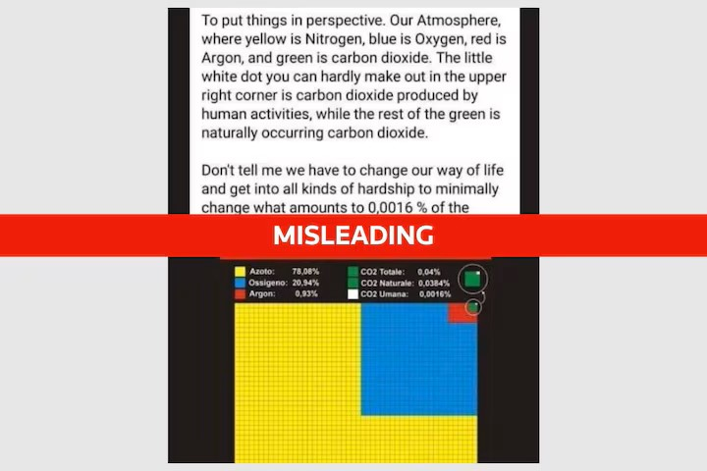
Diagram published by Reuters who is trying to follow the current narrative by identifying the diagram as misleading.
6. The amount and effect of fossil fuel and other anthropogenic emissions have become a hot political potato since it is related to increasing carbon dioxide content in the atmosphere which is directly correlated to global warming. Is this correlation of more CO2 leading to more global warming, correct?
a. The Earth’s various orbital fluctuations may cause the current global warming as is shown by known cooling and warming periods called glacial and interglacial epochs. Some global warming may be a good thing since the next predicted glacial period is around the corner.
b. Researchers note that 18 CO2 jumps measured from air bubbles in ice cores have occurred during extreme obliquity of the planet which is the tilt of Earth’s axis of rotation. Earth’s tilt varies over roughly a 41,000-year period and Earth is presently in a period of high obliquity.
c. As the climate warms, the amount of water vapor is boosted by the rate of evaporation from water sources. Water vapor, a greenhouse gas, keeps increasing in the atmosphere to contribute to more warming which is referred to as a feedback process. The addition of water vapor to the atmosphere is not a human-generated activity.
d. Perhaps God oversees our atmospheric content and not humans. Two of the lowest periods of CO2 concentrations were the famines of Justinian and the Black Plague. We should not worry that Mother Earth is becoming another Venus.
e. All the above reasons are some credible possibilities for suspecting the direct correlation between anthropogenic CO2 emissions and global warming.
The quiz master always invites dialogue. Contact me at dougettinger@verizon.net
Answers: 1. d; 2. c; 3. c and e; 4. b; 5. a; 6. e.

