Ettinger Journals
The Enigma of Earth’s Mega-Continents and Their Connections to the Evolution of Life
An Outline for a New Look at Earth’s Evolutionary History

Douglas Ettinger
Published 6/11/2021

Table of Contents
Why Did Earth’s First Mega-Continent Occur? 3
Why Earth’s Landmasses Do Not Eventually Erode Below Sea Level Over Time 7
The Study of Landforms on Other Planets and Moons 8
The March of the Supercontinents and Their Influence 16
Why the Great Impact Hypothesis Proposed by NASA Did Not Happen 21
The Great Unconformity (GU) 24
The Granite Problem 38
The Earth’s Original Atmosphere and the Origin(s) of Our Present Atmosphere – Present-Day Thinking 50
The Evolution of the Earth’s Atmosphere Based on This Article’s Viewpoint 61
Important Conclusions: Resolution of the First Mega-Continent Enigma 69
References 71

Why Did Earth’s First Mega-Continent Occur?
Why did Earth possess mega-continents with active plate tectonics? No other celestial body possesses such an amazing feature. A good starting point is to develop a theory of how such a raised landmass that only covers ¼ of the globe’s surface above sea level can develop in the first place. I suggest that the proper approach is to try to formulate this theory before trying to answer the more detailed and complex positionings of parts of this migrating mega-continent over time which is ever so popular with geologists today. By starting from scratch at the beginning, science can better answer other associated mysteries: Why do mega-continents amalgamate and disperse on an episodic nature? Why do they migrate both latitudinally and longitudinally moving between hemispheres? Why is each broken piece of this mega-continent currently surrounded by plate boundaries whose interior portion is composed of ancient crystalline rock, called cratons? Why are these continental crusts thicker and composed of mostly granitic rock while the oceanic crust is basaltic?
Such basic questions about Earth’s ancient continents are posed but seldom broached. I will try to resolve these conundrums. But some basic geological diagrams are presented to give readers, perhaps for the first time, a glimpse of 1) the Earth cross-section and structure; 2) the ideas for plate tectonics; 3) the plate tectonic boundaries surrounding the continents; and 4) the cratons of oldest rocks remaining on each sub-continent after the first mega-continent broke apart, wasted, and reassembled several times.
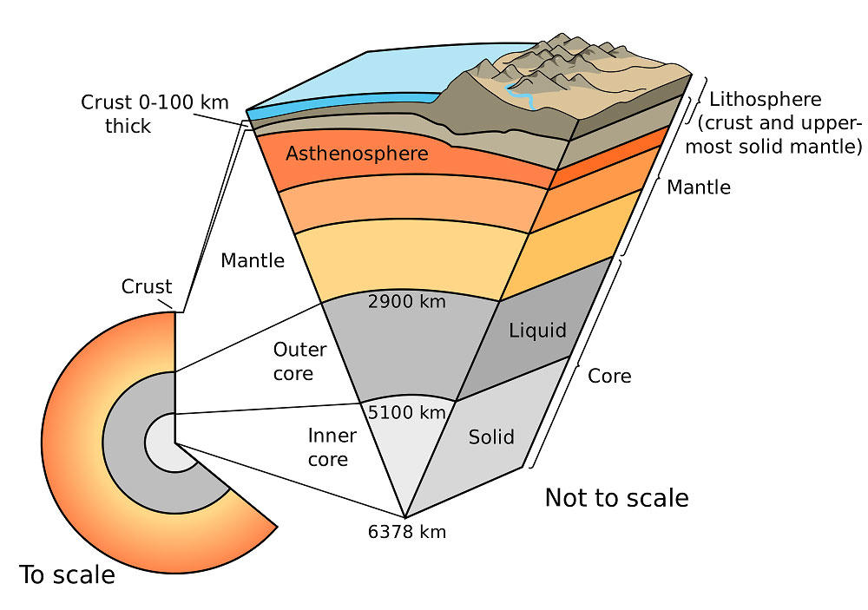
Earth Cross-Section
Image from usgs.gov/media/images/earth-cross-section
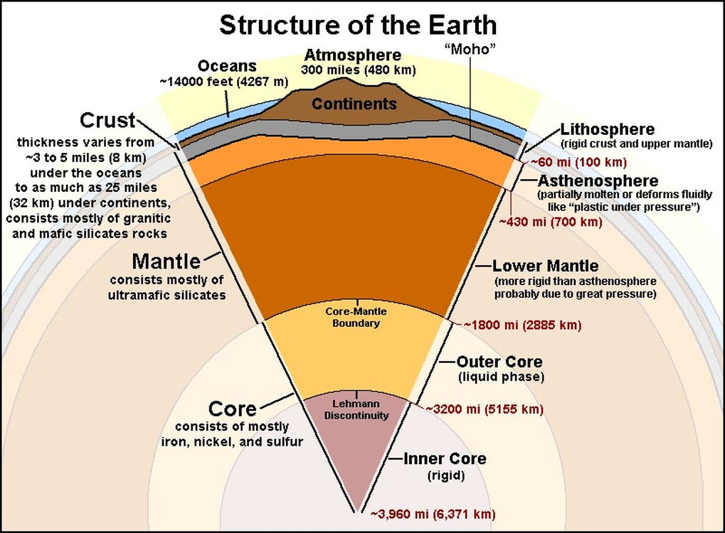
Structure of Earth
Image from Clarkscience8.weebly.com
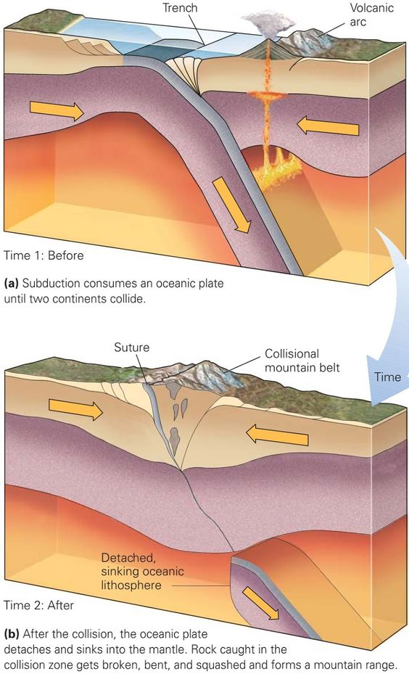
Plate Tectonics: How Plate Boundaries Form and Die
Image from geologylearn.blogspot.com
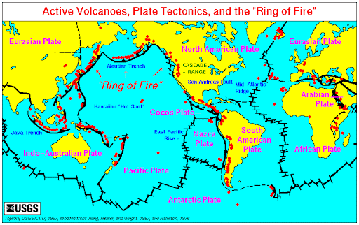
Tectonic Plate Boundaries
Image from USGS
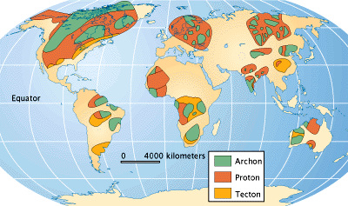
Ancient Cratons, World’s Oldest Rocks
Image from newgeology.us/presentation41.html
Provided is an example of the frustration of current researchers about super-continents. One such researcher is quoted, “The Precambrian history (before 500 million years ago) of the Earth is thought to be punctuated by the assembly and breakdown of at least three supercontinents: Columbia (Nena), Rodinia, and Gondwana. _ _ _ Transcontinental correlation in the Precambrian is a complex endeavor requiring multidisciplinary investigations, primarily involving structure/tectonics, petrology, geochronology, and paleomagnetism. Detailed knowledge of all of these disciplines for regions that were supposedly contiguous as parts of supercontinents is an absolute primary requisite to arrive at any firm conclusion. This is the reason why a wide range of disagreements exists regarding the exact configurations of the supercontinents, despite the overall consensus about their existence.” Competing scientific disciplines do pose a problem and cooperating resolutions can become political, outweighing important collaboration.
Yes, indeed, there is an important consensus of the existence of these ancient continents. However, too much distraction occurs trying to find proposed positions of terrane boundaries and their mutual linkages to the various mega-continents. As is mentioned, the Precambrian eon is very complex especially with isotopic work that may produce inaccurate dating and by having the oldest geological histories mostly erased. More focus is needed to develop a theory for continent-creation that then should be tied closely to the Earth’s formation.
Another consensus that cannot be denied is that the continents do break apart and reassemble in processes called continental drift and plate tectonics. Under the continents is a layer of solid rock known as the asthenosphere or upper mantle. This layer is plastic allowing it to slowly flow under heat convection, so the theory states. This layer extends downward from the base of the lithosphere about 375 miles and can flow both vertically and horizontally, dragging segments of the overlying, more rigid lithosphere along with it. The oceanic and continental crusts or differentiated lighter materials ride on top of the lithosphere, a stronger and less ductile rock that sits on top of the asthenosphere. A debate occurs as to whether the mantle’s convective currents have the strength and power to subduct or push the lithosphere and its connected oceanic crust underneath continental crusts and force upward the tectonic-zone plateaus and mountain ranges. This debate is understood by learning about the Earth’s mountain ranges, plateaus, and plains. Later, the search for more forces is formulated to perform this powerful task as opposed to strictly mantle convective forces, as proposed by consensus science.

Why Earth’s Landmasses Do Not Eventually Erode Below Sea Level Over Time
Many plateaus form as magma deep inside the Earth, which pushes toward the surface but fails to break through the crust. Instead, the magma slowly lifts the large, flat, impenetrable rock above it. The debated forces are thought to cause uplift by the slow collision of tectonic plates that still are lifting areas such as the Colorado Plateau. The author believes other more important forces give power and strength to the lithosphere motions to cause the uplift of plateaus and mountain ranges. There exist about 34 major plateaus in the world which have rich deposits of minerals, proving the continued mixing of the Earth’s crust by plate tectonic processes. Plateaus occur on every continent and take up a third of the Earth's land and change with the process of erosion and wasting. Weather and drainage systems change the plateau’s surface including the cutting of valleys by rivers. Also, the melting of ice sheets on land through the ages creates powerful sub-surface rivers that make fjords and continental shelf canyons. Eventually, plateaus and mountain ranges should all wear down to sea level over millions of years. However, the continuance of continental drift causes the moving lithosphere to pile on top of existing landforms or dive beneath to lift landforms creating episodic plateaus and mountain ranges.
A plateau is an elevated flat land considerably higher than the surrounding area whereas mountains are dramatically raised barriers. Most mountain ranges, excepting volcanic mountains, are also produced by tremendous underlying forces which many geologists have trouble conceiving how the mantle convective forces could be the only or direct cause. Computation of lateral forces creating the necessary upward forces do not agree.
Plains are different configurations and form in different ways. The process of the layers of rock can form both on land and under the sea which is then uplifted above sea level. Some plains form as ice and water erodes, or wears away, the dirt and rock from higher land. Water and ice carry the rubble, rock, and other material, called sediment, down hillsides to be deposited elsewhere. As layer upon layer of this sediment is laid down, plains form. As the layers become thicker and deeper, sedimentary rock forms. The displacement of materials by erosion continues to change isostatic forces that cause either upward or downward movement of the crust. This constant motion of material diving to deep depths is called the “rock cycle” that initially turns from sedimentary rock to metamorphic rock to molten rock, finally becoming igneous and then repeating the cycle via more wasting of the landmasses.

The Study of Landforms on Other Planets and Moons
Geology and its sub-disciplines are now briefly placed on a shelf while the disciplines of chemistry, astrophysics, and planetary science are explored. Do other celestial bodies share the same surface features and cross-sectional properties as Earth? Earth is extremely unique in having two different surfaces – one that is solid and rocky and the other that is liquid water. Diversity in life occurs because of this grand scheme. And our continental landmasses that originated from an ancient mega-continent made this possible. How did this enigma occur? Let’s examine the other celestial bodies for similarities and differences. Their study may lead us to develop a theory about mega-continents. Astrophysicists have imagined interesting theories for mysteries about the other rocky planets and moons – mostly collisions including our very own planet.
Space-age data reveal a similar cross-section for all the terrestrial planets and explored major moons. They all have high-density cores with differentiated outer layers of lighter metals and volatiles. Many cores are hot and molten producing magnetic fields due to induced convective currents of molten liquid and their rotation of the entire body. The lightest volatiles of gases is eventually emitted from the surface to become atmospheres or freeze as solids if the gravity field is strong enough to hold them. If the atmosphere is deep enough its pressure can turn water vapor into liquid oceans such as Earth.
A safe assumption is that all these bodies started as a molten glob of a homogeneous mixture of elements and compounds that began orbiting the Sun at various distances. In the same manner moons of the outer planets were also created. These molten globs either came from accreted disks of dust that originated from supernovae, or were captured as formed bodies that came from the debris of a supernova, or (my favorite) ejected from their parent star or planet due to an electrical plasma Z-pinch theory of unbalanced charges gathered periodically from their magnetosphere. The third method is called a binary mode which probably applies to all solar system bodies except asteroids, comets, and minor planets. Regardless, the molten glob’s origin is not important in this discussion – only that the glob is formed by gravitational compression into a spherical body.
The gravitational compression of any spherical planetoid causes differentiation or the separation of the lighter material with smaller atomic numbers from the heavier metals with larger atomic numbers. This chemical separation by partial melting and outgassing of volatiles is called geological differentiation for any planetoid. As the planetoid’s interior differentiates, less-dense liquids rise from the melt toward the surface and crystallize to form a crust as they are cooled. Inductive reasoning shows this to be true by observing how a blast furnace works. The so-called impurities, or slag, rise to the surface of the molten bath while the separated denser iron underneath is poured into ingots. A chemical periodic chart shows what lighter materials should be found in a planetoid’s crust and atmosphere. These materials are in the first three rows of elements with atomic numbers greater than 20 with the more prolific being H, C, N, O, Al, Si, and S which make up the most abundant compounds: H₂O, NH₃, CH₄, NO₂, SiO₂, and CO₂. The heavier metals, greater than atomic number 20, are found in the cores and deeper in the mantles of planetoids such as Ti, V, Cr, Mn, Fe, Co, Ni, Cu, and Zn.
What we discover on Earth and the other hard celestial bodies is indeed this differentiation described above. But why does Earth have this agglomeration of lighter elements and compounds found not only on its entire surface but also on about ¼ of its unusually elevated surfaces of the globe called continents? The initial separation of the different constituents of planetary materials should result in the formation of distinct and evenly compositional layers globally. Could immense collisions on Earth and other celestial bodies be the reason for large differences in elevation of the various differentiated layers? Let us examine how astrophysicists try to answer anomalous conditions found on the rocky terrestrial planets and major moons. The answers are surprisingly and generally collisions with smaller bodies.
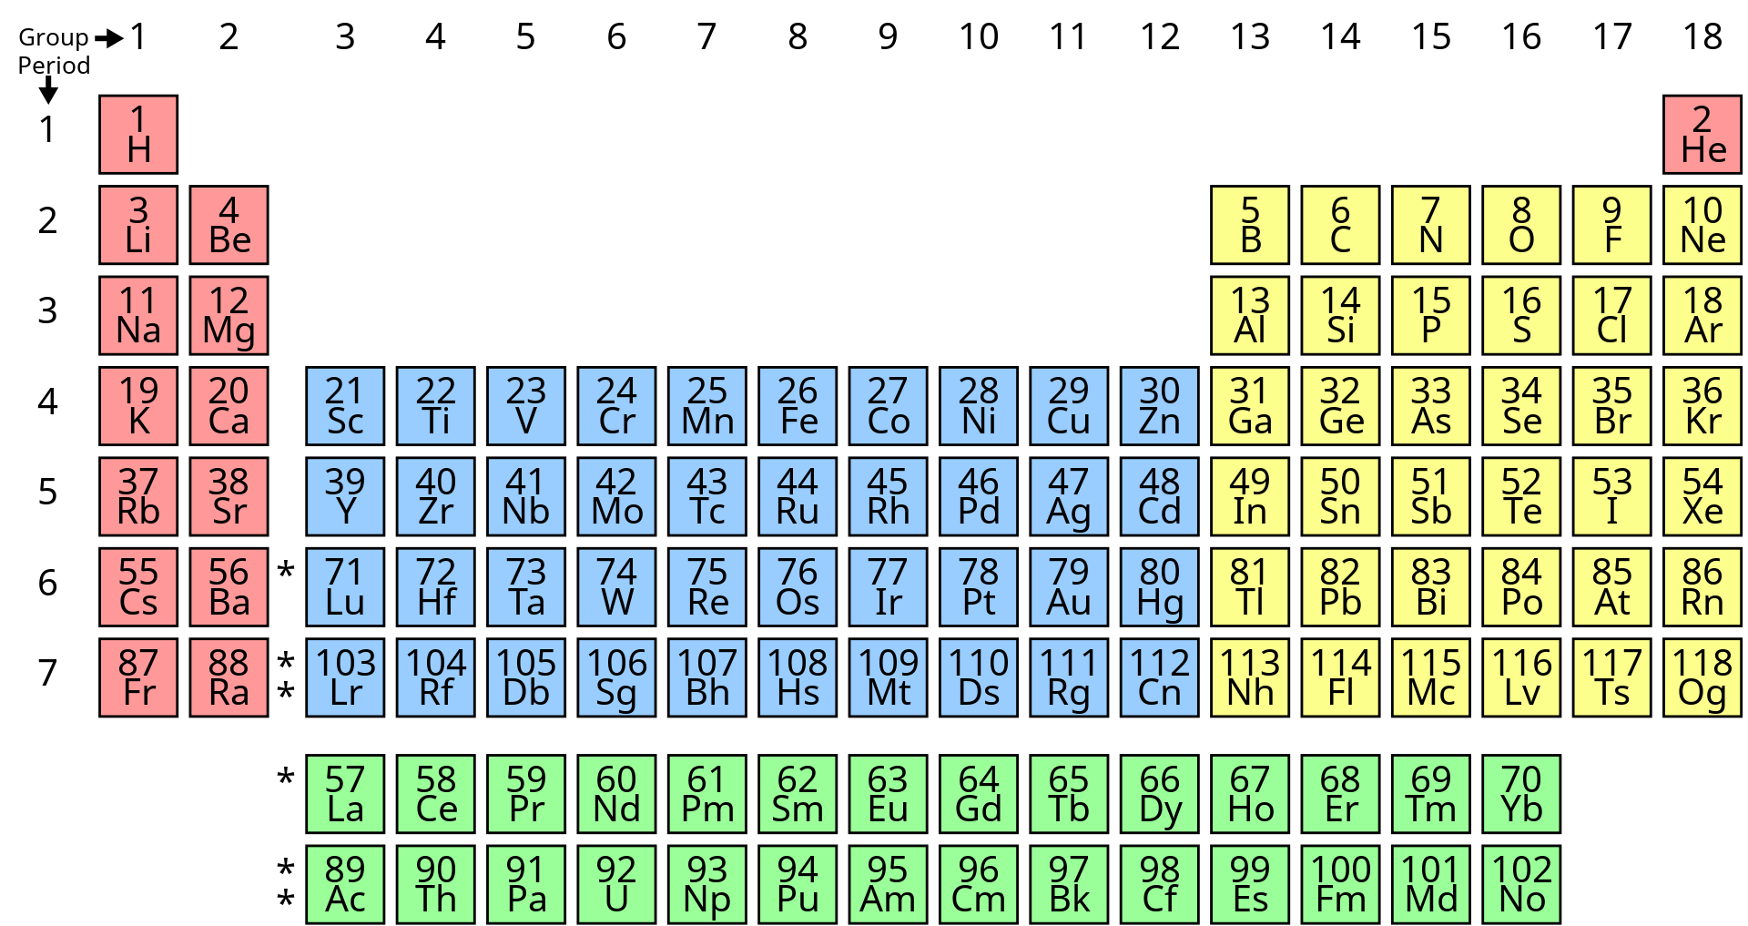
Period Table of Chemical Elements
Image from wikipedia.org
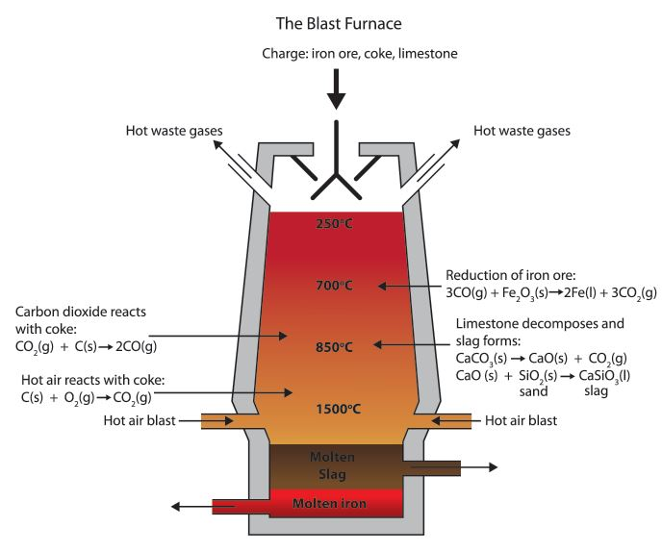
Blast Furnace Process
Image from the International Iron Metallic Association
The Study of Mercury
The first case is Mercury which is much smaller than Earth, but almost as dense. Mercury’s density can be used to determine the detail of its inner structure. Hence, its core must be larger and rich in iron occupying 55% of its volume while for Earth this proportion is 17%. Mercury may have been struck by a planetesimal of about 1/6 that of its original mass which stripped away much of its outer silicate mantle leaving behind mostly core materials.
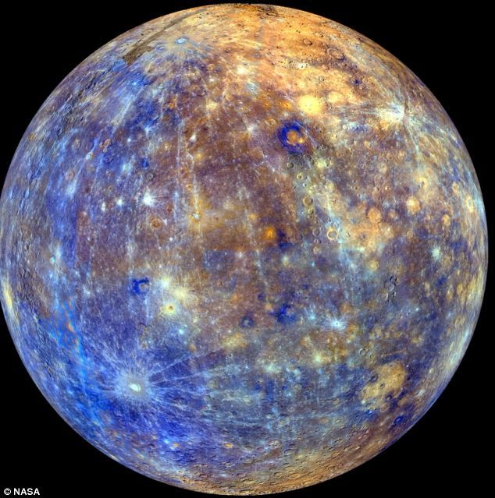
Mercury
Image from NASA and Pinterest
Another likely theory is that as the proto-Sun contracted, temperatures at Mercury’s orbit could have reached 2500 to 3500 K or higher thus vaporizing the mantle which was carried away by the solar wind. Neither theory produces two distinct dis-similar surface elevations and compositions such as is present on Earth. However, similar collisional and vaporizing theories are used for Earth that will be discussed later, but let’s now move to Venus, the next planet away from the Sun.
The Study of Venus
Again, astrophysicists use a collision model early in the planet’s history to explain its retrograde rotation, unlike any other planet. This model includes moon-making. This Venusian moon or moons gradually spiral inward and crash due to a strong solar tide causing Venus to be moonless. Venus has no elevated surfaces comparable to Earth except for numerous volcanic mountains situated on a surface covered with 80% volcanic plains. Earth’s crust is in continuous motion, but without plate tectonics, Venus's crust cannot move to dissipate heat from its mantle. Hence, the mantle heats to critical levels that cause cyclic volcanism that recycles the crust every 600 million years creating a much older crust than on Earth. The reasoning is that with the lack of water, Venus’s crust is too stiff or viscous to allow plate tectonics. However, one cannot forget that Earth has mega-continents that drift and use subduction to recycle the crust. Venus has no such mechanism thereby leaving only outgassing and volcanism to form its surface which should be normally expected for any hard spherical celestial body in the solar system.
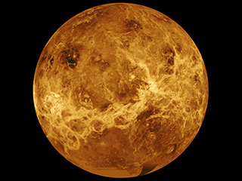
Venus
Image from Universe Today; Space and astronomy news
Venus’s dense atmosphere is composed of 96.5% carbon dioxide and 3.5% nitrogen. Its atmosphere is depleted of radiogenic argon, a marker to mantle degassing which suggests an early end of major magmatism. Evidence of no water is probably due to atmospheric erosion during the first billion years by the solar wind that probably occurred during the Sun’s T-Tauri phase. This T-Tauri phase likely afflicted the atmosphere of all the terrestrial planets assuming that Earth was originally at one AU. If Earth was at 2.7 AU as is proposed, then during the T-Tauri phase its pristine atmospheric gases would be retained. The differences in atmosphere between Venus and Earth are striking. Inductive reasoning leads to Venus’s lack of continental drifting and plate tectonics which could have created a sink for removing CO₂. Also, the lack of nitrogen probably means its meager production was boiled off due to its closeness to the early Sun.
The Study of Mars
Mars is the best-explored celestial body outside of the Moon. Its cross-section is like Earth having a basaltic rock crust similar to Earth's oceanic crust. Mars has a differentiated dense metallic core consisting primarily of iron, nickel, and sulfur. The silicate mantle formed many tectonic and volcanic features. (alternatively, these features may have been created by high-energy electromagnetic plasma discharges having many similarities to an electric arc welding process.) The crust and mantle are now dormant with no global magnetic field. The surface was subjected to the Late Heavy Bombardment with impacts from that era shown on 60% of its area. Martian paleomagnetism is like alternating bands found on Earth’s ocean floors with no clear origin. Possibly a planetary dynamo ceased to function after about 4 billion years. But magnetic reversals are a true mystery on whatever planet they are found.
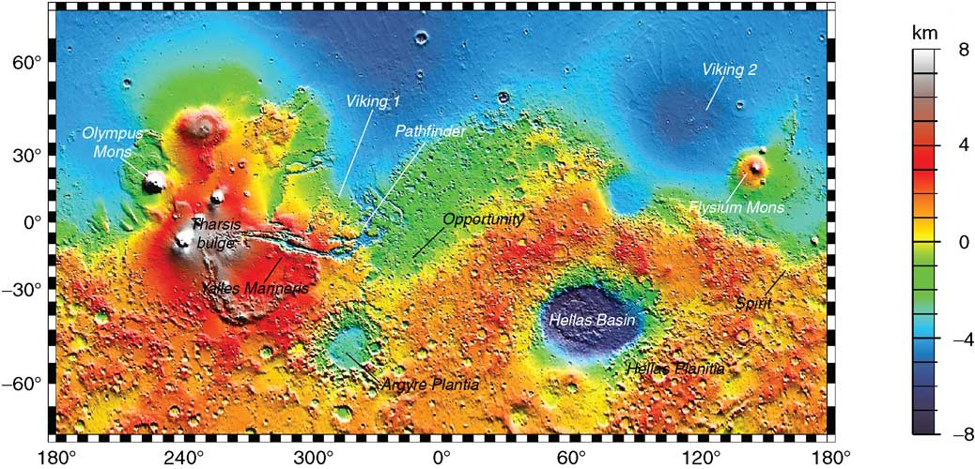
Topographical Map of Mars
Image from the Planetary Society: Mars Orbiter Laser Altimeter (Mola) Map of Mars
The very thin atmosphere of mostly carbon dioxide cannot support any liquid water. Some water may be retained in frozen underground reservoirs. The atmosphere is lacking in N₂ at only 1.89%. What happened to the nitrogen? Perhaps most of Earth’s nitrogen was delivered by its icy impactor which did not occur for any Martian impactor.
Mars cannot escape having its very own immense impact in the Northern Hemisphere shown in blue on the above map. Theory suggests that Mars was struck by a Pluto-sized body about four billion years ago and caused the hemispheric dichotomy. However, this dichotomy exhibits no plate tectonic movement and is only about an average of 6 km (3.7 miles) difference in elevation unlike 29 km (12 miles) for Earth. Why did such a huge impact leave uncracked the Martian crust in the highlands and not generate a rim-like structure centered on the point of impact?
Study of Ganymede
Ganymede, Jupiter's largest moon and most massive moon in the solar system, is a unique body for study. An interesting fact is a theory that this moon contains more water than Earth’s oceans combined. Ganymede, like the Earth, has a liquid iron core with a high electrical conductivity that via convection creates a magnetic field. About a third of the surface is saturated with impact craters and dated to about 4 billion years ago – roughly the time of the Late Heavy Impact period.
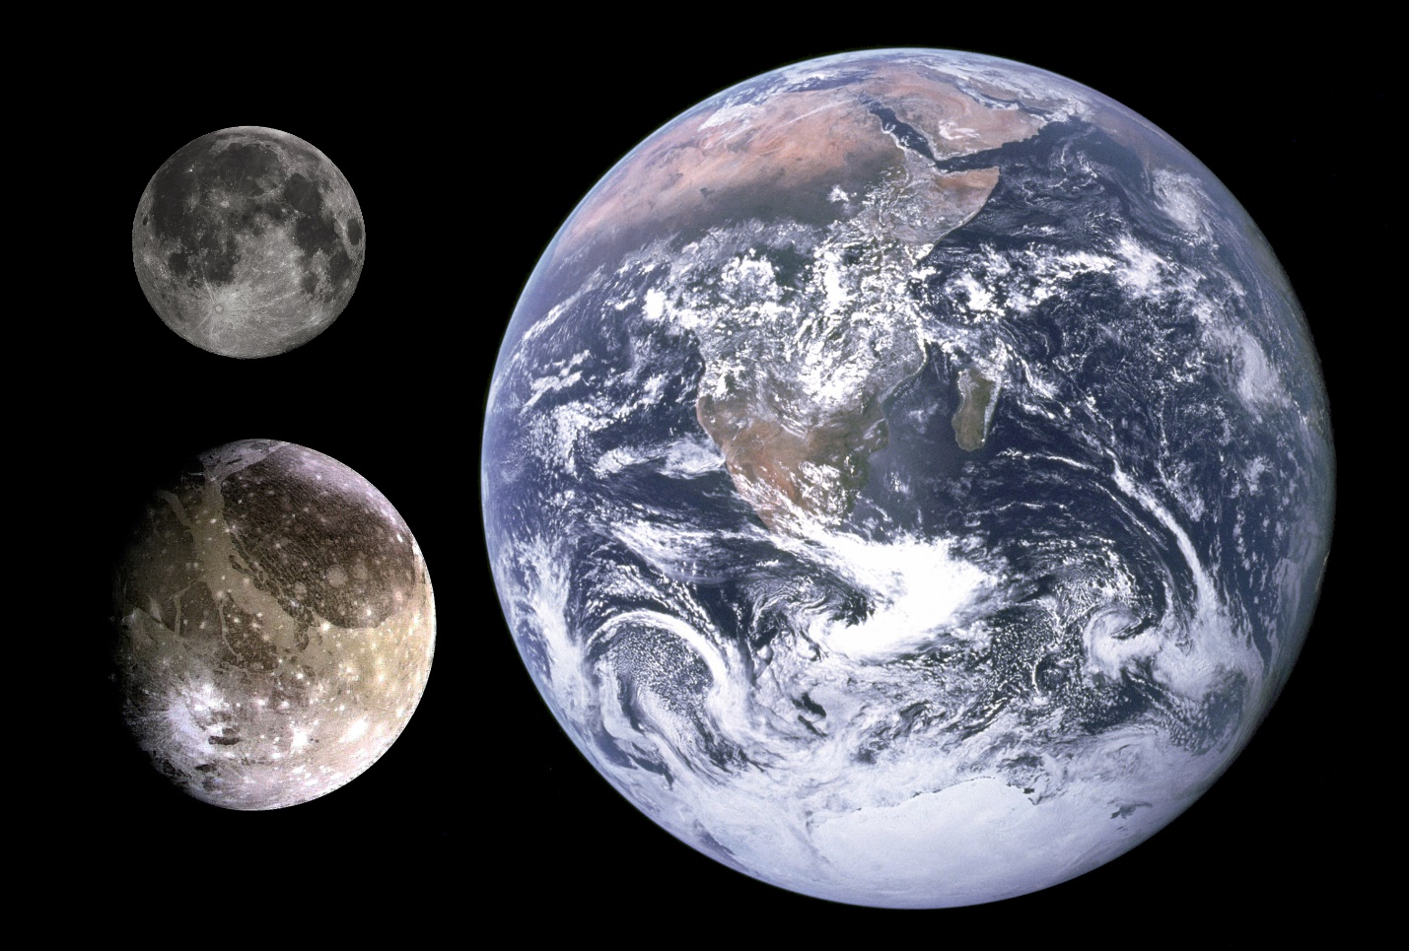
Comparable Sizes of Ganymede, Moon, and Earth
Image from www.wikiwand.com/en/Ganymede_(moon)
The moon is thought to be fully differentiated with an iron-sulfide -iron core, a silicate mantle, and outer layers of water ice and liquid water, not unlike the Earth’s with its outer liquid water ocean. Ganymede's very low moment of inertia factor determines its substantial water content and fully differentiated interior with the stacking of several ocean layers separated by different phases of ice due to an extreme depth of about 800 km. Ganymede’s special crystalline phase structures and its silicate mantle may have been similar to Eath’s impactor and played a large part in producing the mysterious granitic structures found deep in Earth’s crust.
Earth’s impactor hypothesis that occurred at 2.7 AU uses a body similar to Ganymede as a model for the impactor. Such a body may very likely have more water, ammonia, and other lighter volatiles that could be delivered to Earth. This frozen hard-sphere enables penetration into the Earth’s young soft molten mantle to buffer the complete destruction of the two bodies.
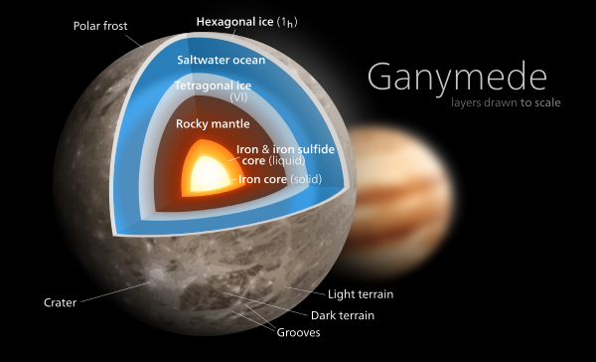
Ganymede’s Cross-Section
Image from Planet for Kids; Free Astronomy Network for Kids
The above study of these celestial bodies through inductive reasoning leads to an interesting theory outlined below:
- All these bodies show an impact history occurring about 4 billion years ago including the Earth and Moon. This impact event is called the Late Heavy Bombardment (LHB). The proposed hypothesis is that Earth was struck by an impactor the size of Ganymede that created the dispersal of rocky debris throughout the inner solar system. The main belt of asteroids at 2.7 AU was also produced at this time by this collision. The age of the oldest cratons on Earth corroborates this event since their plutonic rock was created by the collision at about the same time.
- All these bodies differentiate similarly with lighter material becoming the top layers with the densest materials becoming the cores.
- The lightest volatiles escape to the surface to become atmospheres that meet various fates.
- The geology of the top layers shows significant plate tectonic and continental formation only for Earth. Only Earth shows major elevation differences in the terrain except for volcanic mountains on the other celestial bodies.
- All these bodies have produced theories about major singular collisions including the Earth and Moon. Mars has the theory of impact that created the largest volcanic plain in the solar system, yet it survived the incredible kinetic energy of an impact. Venus’ major collision supposedly caused its retrograde rotation. Mercury’s big collision removed all its lighter metals from its surface. So major impacts should always be within the range of choices and never be ruled out in addressing anomalous conditions.
- Intrusive smaller-grained granitic-type rocks have yet to be discovered by any space probes. This type of granite rock is a special breed only found on Earth and is proposed as the deep infusion of frozen volatile materials into Earth’s mantle.
- Only Earth demonstrates a preponderance of nitrogen in its atmosphere. The thought is that the impactor’s ices brought ammonia and nitric/nitrous oxides that converted to nitrogen as one of its products of reduction to become a stable element for Earth’s atmosphere.
- Only a huge raised and filled impact basin on Earth can address the cause of an ancient mega-continent that dates back to 3.9 billion years ago closely aligning its creation with the Late Heavy Bombardment (LBH). I implore anybody to step forward and give any other plausible reason. The reason that is proposed can also address a whole list of geological mysteries: plate tectonics, continental drift, the Moho layer, geologically/randomly occurring hot spots, a dichotomy of crustal compositions, the formation of granite, early glaciation periods, the Great Unconformity (GU), and atmospheric nitrogen.
The March of the Supercontinents and Their Influence
A listing of the ancient supercontinents is given with the best dating available at this time. Of most importance is the relative progression of the timeline and not the absolute times which may have large errors. The evolution of life-supporting mechanisms occurs because the first mega-continent and its breakup and reassembly into small super-continents make it all possible. The unbalance of the extremely uneven surface of a single humongous crater with a dichotomy of density and unbalanced hemispheric positioning causes the eventually crystallized island-type surface to move or drift and break apart. The forces causing this motion are the Coriolis forces of the spinning Earth exerted on a crustal surface floating on a flexible asthenosphere and a slippery Moho layer. More forces are added by the tidal forces of a closer Moon than today and possibly additional gravity forces of close encounters. The “hunting” of the dynamical system to seek equilibrium causes the frequent episodic back and forth movement of continental drift. The all-important continental drift creates both the continued uplift to maintain the elevations of eroded landmasses and the sinking of the lithosphere/crustal units to thoroughly mix rocks and their minerals to produce the soup of life during the Paleozoic era.
Geologists have for convenience named the supercontinents and the possible dating of their assembly and dispersal. Major proposed events during their timeline are given.
Supercontinent Date (bya) Important Events
Vaalbara 3.9 - 2.5 Predicted existence.
3.6 Formation of solid crust.
3.2 – 2.5 Formation of ocean and continental crust. 2.9 – 2.7 Possible glaciation called Pongola.
Kenorland 2.5 – 2.0 Several cratons merged.
2.3 First atmosphere on record.
2.4 – 2.1 First glaciation period call Huronian during
continental breakup.
Columbia 1.8 -1.5 Size was estimated and huge asteroid strike
discovered.
1.6 – 1.2 Protozoic era with breakup and active
mountain ranges.
(The Great Unconformity) 1.6 – 0.7 Span of 0.9 billion years missing from the rock
record.
Rodinia 1.4 – 1.2 Assembly of continent.
1.4 Earliest multi-cellular organisms.
1.2 – 1.0 Eukaryotes reproduce sexually.
1.0 – 0.7 Breakup of continent.
0.8 Huge rise in O₂ (GOE 2)
0.7 First fauna of worms appear.
(GrandCanyon Supergroup) 1.4 – 0.7 Coastal sedimentary rock forming a
angular unconformity.
Pannotia 0.65 – 0.54 Formation of proto-Gondawana and proto-
Laurasia, Baltica, and Sibera.
0.63 – 0.54 Ediocaran biota emerged.
0.72 – 0.55 Cryogenian Ice Age called the Snowball Earth;
most land and poles are covered with ice.
0.54 – 0.48 Cambrian Period with the appearance of
trilobites; the birth of two separate oceans
causing increased mountain building.
0.525 – 0.270 The layered Paleozoic rock layers found in the
Grand Canyon above the Great Unconformity.
Ten or more other unconformities are found
here.
0.48 – 0.44 Spread of algae and mollusks during
Ordovician Period.
0.46 – 0.43 Andean Ice Age
(mass extinction) 0.44 During Ordovician – Silurian boundary
0.43 – 0.42 Spread of fish and plants during Silurian Period
0.20 – 0.36 First land vertebrates and insects during
Devonian Period.
(mass extinction) 0.365 Devonian period had great loss of life.
0.36 – 0.30 Explosion of organisms with an increase in
amphibians.
0.36 – 0.26 Karoo Ice Age
0.30 – 0.25 Formation of coal occurred during the
Carboniferous Period.
Pangaea 0.30 – 0.25 Separate supercontinents collided to form
Pangaea outline.
(mass extinction) 0.252 The greatest mass extinction at the Permian-
Triassic boundary.
0.25 – 0.20 Pangaea beginning to break apart with climate
warming; fauna became isolated.
0.25 – 0.20 Large marine predators, spread of amphibians
and reptiles during the Triassic Period.

Supercontinent Date (bya) Important Events
(mass extinction) 0.210 During Triassic – Jurassic boundary.
0.20 – 0.145 Spread of large lizards and dinosaurs during
Jurassic Period.
0.20 – 0.145 N.A. & S.A. break apart from Africa, and
India and Australia break apart.
0.65 Oceans grow in size between continents during
the Cretaceous Period further helping
to separate species of land animals.
(mass extinction) 0.65 Great loss of life-ending the Age of the
Dinosaurs between the Cretaceous and
Tertiary Periods.
0.026 beginning of Quaternary Ice Age.
(mass extinction) 11,500 years ago Holocene mass extinction - known for the
disappearance of mammoths and other large
fauna.
The above case study shows that the marching or drifting continents unexpectedly are faster in the latter years of Earth’s history. Also, more and longer periods of detectable glaciation occurred in the last 700 million years. And do not forget that six major mass extinctions occurred in this same period. These events are all interconnected. Study the following proposed maps of 1) the first ancient continents; and, 2) the assembly and breaking apart of the last mega-continent, Pangaea. These maps show more compact episodic groupings that then come apart finally to form the present continental arrangement which is still not finished.
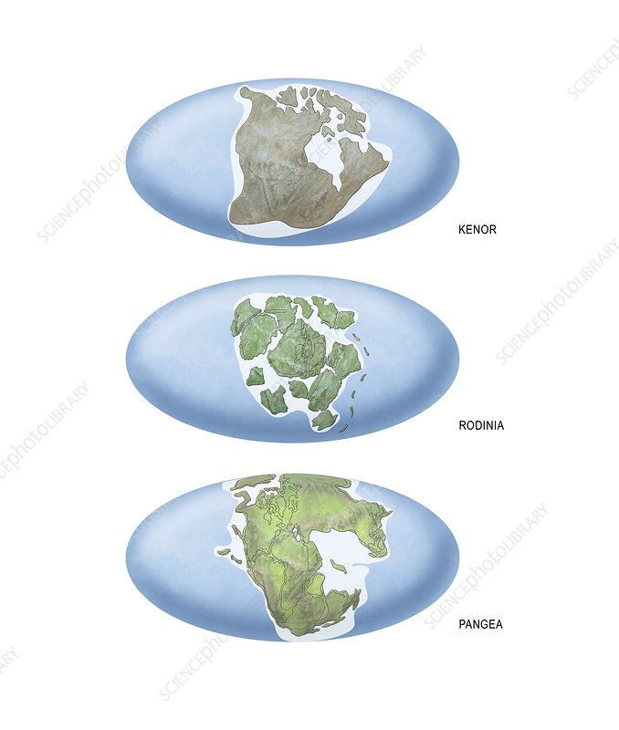
Ancient Super-Continents
Image from sciencephoto.com/Earth’s supercontinents, artwork
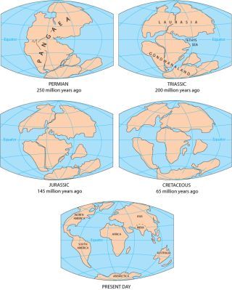
Assembly and Breakup of Pangaea
Image from livescience.com and the U.S. Geological Survey
The formation of a second ocean and the solidification of a continental crust took about 1.5 billion years. The possible solidification of granite plutons ended about 1.6 billion years ago (bya) as indicated by the global Great Unconformity taking about 2.3 billion years. The best estimate for the beginning and assembly of supercontinents Vaalbara at 3.2 bya, Kenorland at 2.5 bya, Columbia at 1.8 bya, Rodinia at 1.4 bya, Pannotia at 0.65 bya, and Pangaea at 0.30 bya show the quickening and maturation of continental drifting. The dispersal of heat energy took eons but was eventually accelerated and aided by the development of a crust crystallizing on top of the lithosphere that acted as a unit, cracked, and subducted causing more mixing and cooling of both the crust and the upper mantle. The spawning of more volcanism accelerated the cooling of the crust and the stiffening of the lithosphere which could then dive more deeply into the asthenosphere and accelerate the rock cycle.
The subduction zones and erupted hot spots caused episodic cycling of volcanoes which emitted ash and dust into the atmosphere to shield the Sun’s radiant heat and cause glaciation. Glaciation would not have been initiated unless raised landmasses gathered more and more snow each year to produce ice sheets on land. At 2.5 bya, oxygen helped replace the greenhouse gases of CO₂ and methane which also helped cyclic ages of glaciation. Without the raised landmasses of the supercontinents, ice sheets would have only occurred in the polar regions. An Earth completely covered with liquid water at 1 AU can only freeze at the poles due to heat convection in both the ocean and atmosphere. The ice sheets on land caused episodic erosion and wasting of the elevated surfaces. The ice would retard erosion for extremely long periods but then would eventually trap heat from the mantle that in turn would create dramatic erosion underneath the ice creating such land features as fjords and continental shelves with canyons. Direct evidence of this cyclic glaciation that stopped wasting for long periods and then accelerated erosion is the unconformities of different layered rocks in the Paleozoic period. The major sedimentary rock layers stacked on top of each other are uniquely different, indicating a long period when one type of erosion ceased and another started up to produce entirely different rocky minerals and colors for the next overlying layer. Why? Episodic glaciation of landmasses is probably the best answer.
The cause of the great mass extinctions during the last 500 million years is anyone’s guess. But certainly one can point to certain causes and perhaps to a combination. The ice ages certainly placed stress on both the flora and fauna, with the lack of radiant heat and light. The covering of landmasses with ice squeezed the animals into smaller and smaller niches. The dust and ashes of extreme volcanism brought about by the increased continental drift and resulting plate tectonics would also add to blocking the Sun and greatly reducing photosynthesis and the O₂/CO₂ cycle. One certain blame was an asteroid strike during the mass extinction between the Cretaceous and Tertiary eras.
Why the Great Impact Hypothesis Proposed by NASA Did Not Happen
Inductive reasoning provided the previous arguments for developing the new impact hypothesis of Earth struck and penetrated by an icy rogue minor planet to displace Earth’s orbit, change the spin axis tilt, and create a mega-continent from its immense cratering. This idea is called the Earth’s Metamorphosis Hypothesis or EMM. Deductive reasoning will now test the accepted NASA hypothesis, called the Giant Impact Hypothesis or GIH. The Moon and Earth system is very different from other planet-satellite systems. NASA, through its Apollo Missions, was hoping to develop an idea for their formation. Researchers become stuck on the paradigm that the Moon was truly a satellite of Earth, but could not use their favored nebula hypothesis of accretion disks forming satellites because the Moon was too large and too far away. Capture and binary methods could not be used because the Moon had too much angular momentum. NASA finally settled on a combination collision and capture mode whereby the glancing collision would slow the body enough to succumb to orbiting the parent planet. NASA was hoping that data collected from the Apollo Missions would prove this hypothesis. Struggling to make this idea work, they construed another version where most of the Earth’s mantle was vaporized and flung high enough so that the orbiting Moon would sweep up some of the Earth’s mantle before it fell back to the surface. This idea also failed due to isotopic studies of potassium. The most recent version in a 2016 analysis of lunar rocks suggests that the impact may have been a direct hit, causing a thorough mixing of both parent bodies. In this significantly newer version, an orbiting debris cloud coalesces into the Moon, but no study corroborates how it achieves its current orbital parameters.
A review of the failure by NASA’s GIH is given:
- Computerized data showed that a glancing body could be slowed enough for capture and orbiting and sweeping most of the collisional debris. However, to achieve the correct angular momentum exchange, the Earth would have to increase its velocity of rotation to a 5-hour day. This result is impossible because, more than 4 billion years after this event occurred, the Earth cannot slow down to our present 24-hour day.
- Initially, the scar resulting from the glancing collision was supposed to create the Pacific Ocean basin. However, subsequent oceanography research showed that the ocean floor could not be older than 100 million years due to the constant motion of continental drift.
- A glancing collision should have Earth’s spin axis and Moon’s orbital plane matching which is not the case.
- Any version of collision should address Earth’s first mega-continent, an atmosphere of nitrogen and water vapor, global volcanism and plate tectonics, and the concentration of formation of granite cratons in the center of each of the broken pieces of this mega-continent. NASA’s GIH does not address any of these planetary anomalies which the EMM does.
- Astronomers think the collision between Earth and its GIH-impactor happened at about 4.4 to 4.45 bya; about 0.1 billion years after the Solar System began to form and does not provide a connecting reason for the Late Heavy Bombardment (LHB) that occurred about 3.9 bya. The new EMM collision hypothesis provides the reason for the Inner Solar System’s Late Heavy Bombardment or LHB and aligns with the oldest rocks on Earth and many carbonaceous meteorites.
- Regardless of the speed and tilt of the Earth's rotation before the impact, NASA’s best acceptable version of a direct hit would have experienced a day some five hours long after the impact, and the Earth's equator and the Moon's orbit would have been coplanar. Also, in this version, the ring of coalescence would not have exceeded much farther than the Roche limit which cannot explain its present enormous distance from Earth.
- In 2001, a team at the Carnegie Institution of Washington reported that the rocks from the Apollo program carried an isotopic signature that was identical with rocks from Earth, and were different from almost all other bodies in the Solar System. However, in science, a very low probability of a situation points toward an error in the theory, so NASA’s effort has been focused on modifying the theory to better explain this anomaly that the Earth and Moon are composed of nearly the same type of rock – considered an impossibility in solar system formation.
- The explanation that is never imagined by the researchers is that the proposed collision by an icy minor planet in the main belt of asteroids brought debris with Earth when it was displaced to its new orbit near the Moon. This debris was then eventually swept up as Earth orbited past the Moon each time until their orbital velocities equalized. This not only explains similar compositions due to isotopic studies but also explains the mares on the Moon being molten for about 900 million years while the debris of meteorite collisions continued for that period.
- If, during the direct-hit version, the Moon should have formed mostly from the mantles of the Earth and the impactor, while the core of the impactor accreted to the Earth. It is noteworthy that the Earth has the highest density of all the planets in the Solar System except Mercury; the absorption of the core of the impactor body explains this observation, given the proposed properties of the early Earth and NASA’s impactor that is called Theia. However, the dense liquid core of the Moon, although smaller, but similar to other terrestrial planets cannot be explained. The newly proposed collision model called the Earth’s Metamorphorism Hypothesis (EMM) uses a Moon typically formed like the other terrestrial planets. The more-than-normal average density of the Earth is explained easily because its impactor’s core did indeed accrete with the Earth’s core including most of its lighter mantle.
- Moon rocks contain more heavy isotopes of zinc, and overall less zinc, than corresponding igneous Earth or Mars rocks, which is consistent with zinc being depleted from the Moon through evaporation, as expected for the giant impact origin. However, this result can also agree with the repeated smaller collisions of debris brought by Earth to the Moon’s orbital location.
- A convincing number of compositional inconsistencies should without any doubt disprove NASA’s GIH. The EMM hypothesis recognizes that the Moon was originally a terrestrial planet and its surface geology does not need to explain how its chemistry matches a major collision with Earth and the mixing of the resulting materials. The Moon has its own unique signature of formation, and then subsequently was disturbed by low-velocity falling debris coming from Earth’s collision in another location that is identified as the LHB occurring around 3.9 bya. These compositional inconsistencies from Wikipedia in 2021 are listed below:
- The ratios of the Moon's volatile elements are not explained by the giant impact hypothesis. If the giant-impact hypothesis is correct, these ratios must be due to some other cause.
- The presence of volatiles such as water trapped in lunar basalts and carbon emissions from the lunar surface is more difficult to explain if the Moon was caused by a high-temperature impact with Earth.
- The iron oxide (FeO) content (13%) of the Moon, intermediate between that of Mars (18%) and the terrestrial mantle (8%), rules out most of the source of the proto-lunar material coming from the Earth's mantle.
- If the bulk of the proto-lunar material had come from an impactor, the Moon should be enriched in siderophile elements, when, in fact, it is deficient in them.
- The Moon's oxygen isotopic ratios are essentially identical to those of Earth. Oxygen isotopic ratios, which may be measured very precisely, yield a unique and distinct signature for each solar system body. If a separate proto-planet Theia had existed, it probably would have had a different oxygen isotopic signature than Earth, as would the ejected mixed material.
- The Moon's titanium isotope ratio (50Ti/47Ti) appears so close to the Earth's (within 4 ppm), that little if any of the colliding body's mass could likely have been part of a Moon-type impactor.
- Alternative hypotheses suggested at various times for the Moon's origin are - that the Moon was spun off from the Earth's molten surface by centrifugal force; that it was formed elsewhere and was subsequently captured by the Earth's gravitational field; or that the Earth and the Moon formed at the same time and place from the same accretion disk. None of these hypotheses can account for the high angular momentum of the Earth-Moon system.
With so many ideas swirling around, NASA is having difficulty sorting out the correct proposal for the formation of the Earth-Moon System. NASA is dealing with paradigms that strongly resist changes in their thinking. The worldviews underlying the theories and methodology of astrophysics and planetary science are deeply entrenched. These paradigms are:
- The Moon was never a planet.
- The Earth was never displaced from another orbit by collisional forces.
- The impact of a rogue minor planet making a raised rimmed crater to later become a mega-continent is not imagined.
- A rogue planet could not possibly deliver more precious volatiles such as water and nitrogen and methane to make up the ancient ocean and atmosphere.
- The origin of Earth’s water is due to the planet’s residing close to the solar system’s “frostline” at 2.7 AU during the hot T-Tauri phase of proto-star formation
Such paradigms must be removed. I hope humankind will eventually seek the explanation of this article to understand how from chaos, our genesis of Earth and life came to be. Strangely enough, this storyline is in alignment with parts of the book of Genesis in the Old Testament Bible.
Returning to Earth’s geology, more evidence is now gathered to convince the hard-core believers of their false ingrained paradigms about the first mega-continent. The premise of an original continent forming after the Earth’s birth about 3.90 billion years ago by a huge impactor is continued. This all-important event created the scenario for life’s beginnings. The supporting geological topics of the Great Unconformity (GU) and the Granite Problem follow.
The Great Unconformity (GU)
Seen from Desert Tower at the Grand Canyon, the Great Unconformity is the boundary between the flat-lying Tapeats sandstone or overlying Paleozoic rocks and tilted rocks of the Grand Canyon Supergroup of sedimentary rocks. The rocks below this boundary found worldwide are the so-called basement igneous and metamorphic rocks of the continental crusts.
The rock layers in the Grand Canyon Supergroup have been tilted, whereas the other rocks above this set are horizontal. This is known as an angular unconformity. The top of these sediment layers was then completely eroded, forming the GU. These layers are sedimentary, and primarily sandstone which is softer and weaker than the igneous rocks underneath. The Great Unconformity represents about 1.2 billion years of missing rock record, either due to erosion or non-deposition. How could this happen?
An unconformity is a contact between two rock units in which the upper unit is usually much younger than the lower unit whereas regular unconformities exist between sedimentary rocks or metamorphic rock groups and are generally parallel to each other and closer in predicted age. In the case of the GU, sedimentary rock lies above and was deposited on the pre-existing and eroded metamorphic and igneous rocks after about 1.2 billion years passed.
Generally, the accepted viewpoint for geologists is that during the early Cambrian Period, shallow seas repeatedly advanced and retreated across the various raised continents, gradually eroding softer surface rocks to uncover rising fresh harder igneous rock from within the crust. Exposed to the surface environment for the first time, the initial crustal rocks reacted with air and water in a chemical weathering process that released ions such as calcium, iron, potassium, and silica into the oceans, changing the seawater chemistry. The basement rocks were later covered with sedimentary deposits from those Cambrian seas, creating the boundary now recognized as the Great Unconformity. Evidence of changes in the seawater chemistry is captured in the rock record by high rates of carbonate mineral formation early in the Cambrian, as well as the occurrence of extensive beds of glauconite and potassium-, silica-, and iron-rich minerals that are much rarer today.
The influx of ions into the oceans also likely posed a challenge to the organisms living there. Any living organism has to keep a balance of these ions to function properly. If organisms have too much of one ion then they have to get rid of it, and one way to get rid of it is to make a mineral. The fossil record shows that the three major biominerals — calcium phosphate, now found in bones and teeth; calcium carbonate, in invertebrate shells; and silicon dioxide, in radiolarians — appeared more or less simultaneously around this time and in a diverse array of distantly related organisms.
The time lag between the first appearance of animals and their subsequent acquisition of biominerals in the Cambrian is notable. Shanan Peters, a geoscience professor at the University of Wisconsin-Madison, says, “It’s likely biomineralization didn’t evolve for something, but evolved in response to something — in this case, changing seawater chemistry during the formation of the Great Unconformity. Then once that happened, evolution went into in another direction.” Today those biominerals play essential roles as varied as protection (shells and spines), stability (bones), and predation (teeth and claws). Together, the results suggest that the formation of the Great Unconformity dated at almost the same time may have triggered the well-known Cambrian explosion of life. But why was the deposition of rock stopped for about 900 million years above the GU?
At the same time the super-continent, Columbia, is dated as forming and breaking up between 1.8 and 1.5 billion years ago (bya) and showed active mountain formations. The proposed idea is that the plutons of intrusive granite had risen high enough inside the mantle material of the giant crater of the super-continent to eventually begin crystallizing due to lessened temperature and pressure. The pushing upward due to phase expansion and isostatic forces on the new crust of the volcanic plains on top created higher elevations that collected glaciers. Colder climates were caused by the frequent release of volcanic dust and ash. The combination of glaciation and weather erosion dependent on latitude and height caused accelerated wearing and washing away the softer sedimentary rock above the hardened GU interface. Many raised, level plateaus inside the impact crater became covered with ice sheets that prevented further erosion. Some of the first glaciations, called the Huronian, occurred about 2.3 to 2.0 bya. The softer crustal material was displaced to the surrounding oceans. The coastal sediments would eventually end up going for a ride on top of the lithosphere into the depths of the asthenosphere to create episodic rock cycles. However, plate tectonics was delayed because the lithosphere was not ready.
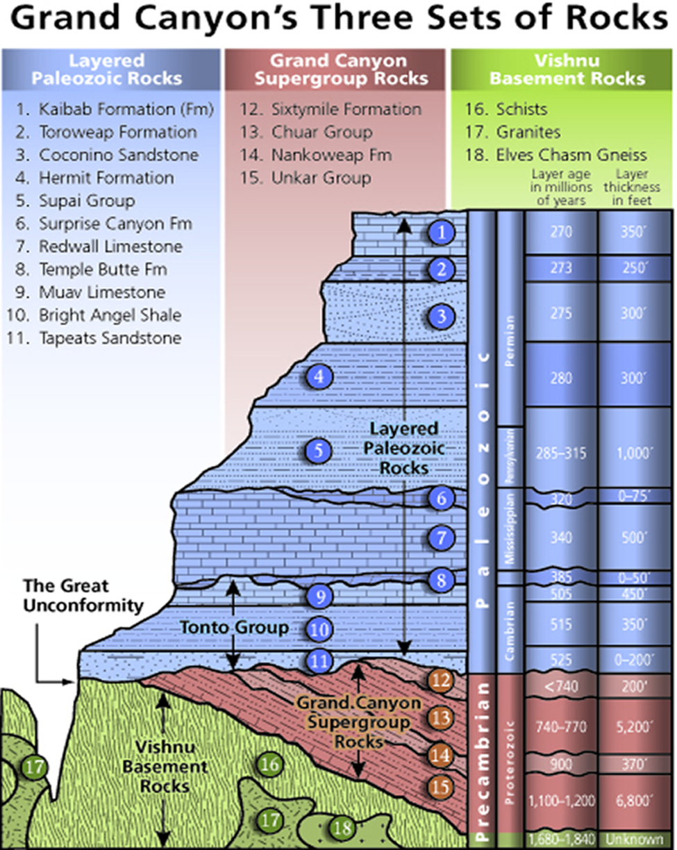
Grand Canyon Layers of Rock
Image from usgs.gov; stratigraphic column of Grand Canyon Rocks
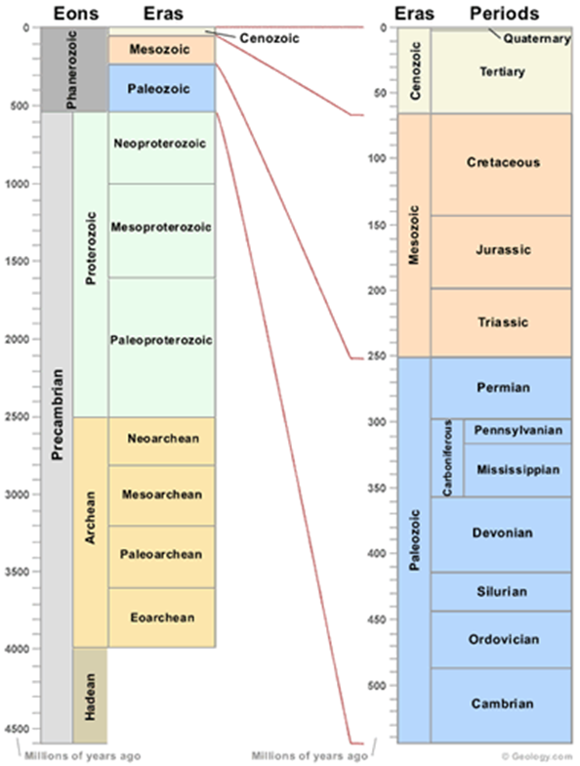
Geological Eons, Eras, and Periods
Image from geology.com; Geologic Time Scale, Geologic Time Line
The lack of new deposition was due to the slowing of volcanism, the continued erosion of softer materials, and the ceasing of rising plateaus and mountains until the lithosphere was cool enough and rigid enough to split into pieces and take the newly formed parts of broken continental crust for the ride that geologists call continental drift. The lithosphere all through this period was getting increasingly differentiated, harder, and thicker. The separation and detachment of the lithosphere from the still hotter asthenosphere inside the impactor crater were slowly occurring. The newly-formed lithosphere was also collecting underneath trapped volatiles that joined from all sides called the Moho layer. This slippery layer would assist in the motion of the lithosphere after it was rigid enough to break apart and cause continental drifting. The Moho layer formed from less dense volatiles rising over longer time spans to the surface and being trapped by the old and new solid lithosphere that sealed their further rise. Much of this lighter magma would be bled off into dikes going to higher magma chambers that would become the worldwide random mysterious geological hot spots. These hot spots notably formed island chains, Yellowstone, the Deccan Traps, and Siberian traps, among other surface granitic extrusions later in Earth’s history.

The below phases of the impactor penetration into Earth’s mantle show the various transformations.
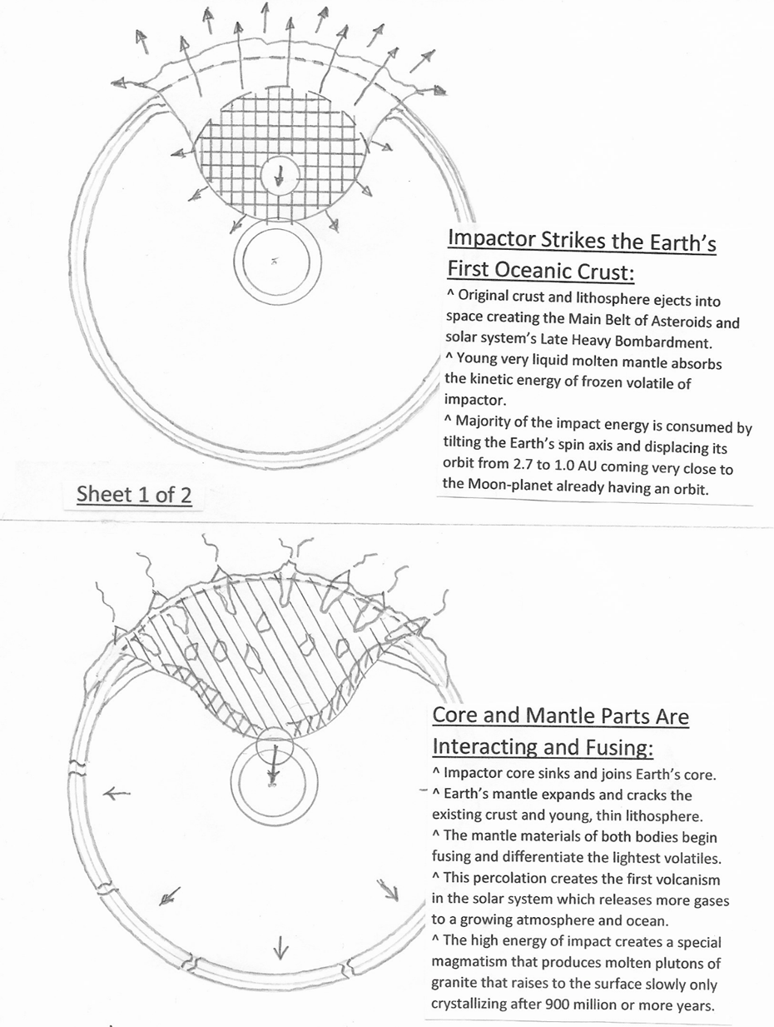
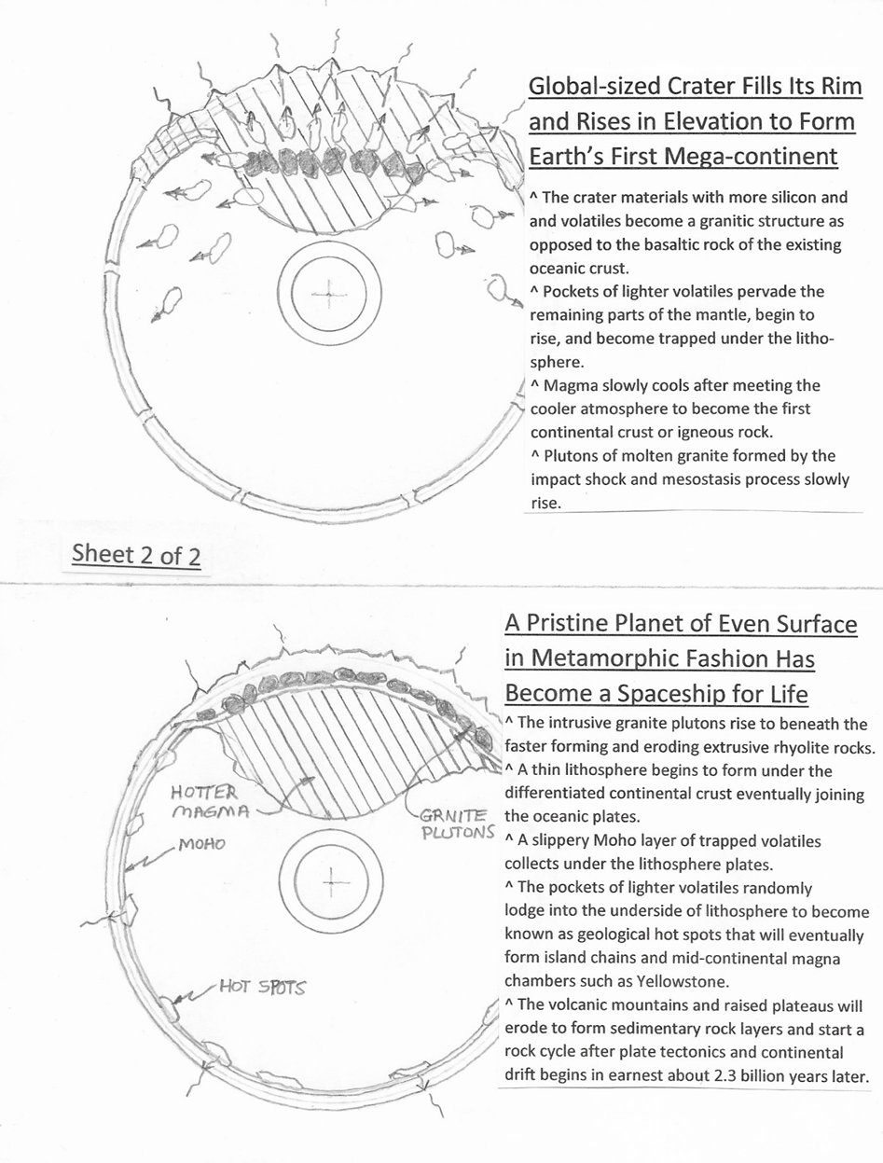

The motion of the lithospheric plates, with either their load-bearing oceanic or thicker, less dense continental crusts, was created by the dynamical forces of isostatic changing loads of ocean height, sediments, and ice sheet thickness; Coriolis forces creating an unbalanced crust on the surface of a spinning body; the tidal acceleration due to a closer Moon and Sun tides; and large asteroid strikes in which some are known, and possibly unknown close encounters with other celestial bodies. The Earth is a dynamic system of interrelated, interdependent, and interacting parts, forming a collective entity. These interacting parts are the geosphere, hydrosphere, atmosphere, cryosphere, and biosphere. Mathematically, this system is a collection of particles whose state varies over time and obeys differential equations involving time derivatives. To predict the system's future behavior an analytical solution may be integrated over time. If mathematicians had the right model of impactor penetration in mind, perhaps continental drift for the geosphere, the largest system, could roughly be predicted. The continuous episodic breaking apart and reassembly of the mega-continent is caused by a nonlinear piecewise system that exhibits completely unpredictable behavior called chaos. The geosphere’s chaos is still present today, but hopefully to a lesser extent.
“This feature explains a lot of lingering questions in different arenas, including the odd occurrences of many types of sedimentary rocks and a very remarkable style of fossil preservation. And we can’t help but think this was very influential for early developing life at the time,” says Robert Gaines of Pomona College. Fossils are formed in several different ways, but most are formed when a plant or animal dies in a watery environment and is buried in mud and silt possibly being caught in surprise flooding. Soft tissues quickly decompose leaving the hard bones or shells behind. Over time sediment builds over the top and hardens into rock. Prokaryotes were the earliest life forms, simple creatures that fed on carbon compounds that were accumulating in Earth's early oceans coming from the CO₂-ladened atmosphere. Slowly, other organisms evolved that used the Sun's energy, along with compounds such as sulfides, to generate their energy. These early organisms on ocean bottoms also gained the special ions that eroded off the mega-continent into the ocean.
Dating the GU boundary has special problems. The three basic laws of relative rock dating are the law of superposition, the law of crosscutting, and the law of inclusions. Also, the dating of the actual fossils is commonly used in paleontology. Potassium-argon dating is a form of isotopic dating commonly used in paleontology. Scientists use the known natural decay rates for isotopes of potassium and argon to find the date of the rocks. The zircon crystals from Australia's Jack Hills are believed to be the oldest thing ever discovered on Earth. Trace elements found in the zircons suggest they came from water-rich, granite-like rocks. But how did the water survive in such a super-heated environment? The answer comes from the tremendous force of a frozen impactor pushing its ice water and other light volatiles into the less viscous mantle of young-Earth radically changing the chemical interface with unusual phase and mineralization changes. Water would have rapidly sought the surface of a body through differentiation for a normally formed molten glob but not in this case.
It's often considered much easier to date volcanic rocks than the fossils themselves or the sedimentary rocks they are found in. So, often layers of volcanic rocks above and below the layers containing fossils can be dated to provide a date range for the fossil-containing rocks. Together with stratigraphic principles, radiometric dating methods of potassium-argon or uranium-lead isotopes are used in geochronology to establish the geologic time scale. The half-life of carbon-14 is 5,730 years, so carbon dating is only relevant for dating fossils fewer than 60,000 years old. However, there are suspicions that the over-thrusting and subducting of rock layers obscure an accurate timeline.
The Great Unconformity (GU) is one of geology’s deepest mysteries. It is a gap of missing time in the geological record between 100 million and 1 billion years long, and it occurs in different rock sections around the world. When and how the GU came to be is still not completely resolved. However, Michael DeLucia, a specialist in plate tectonics at the University of Illinois of Urbana-Champaign, has developed an excellent hypothesis involving the spreading and uplifting of mega-continents. Their evidence implies a culprit behind all of the missing rock: global tectonic uplift associated with the breakup of the ancient supercontinent Rodinia.
This means there was probably a humongous amount of erosion. Forces of nature seek to even out large differences in topography. Any sudden large-scale uplift, they surmise, would have exposed relatively more Rodinian rock than normal. The new evidence shows 6 to 8 vertical kilometers of fresh rock material uplifting at the end of the Precambrian. As time passed, this weathering and erosion carved the GU.
Other Earth scientists, Stephen Marshak and William Guenthner, look at the same contact regions between rhyolite and granite in Missouri. These rocks rest below the Great Unconformity boundary as it occurs on the Ozark Plateau in North America. Where the GU horizon exists on the planet, the difference in rock type above and below the horizon is striking: In the Grand Canyon, the Precambrian Vishnu Schist is warped and twisted compared to the Cambrian Tapeats Sandstone that overlies it. On the Ozark Plateau, at the team’s field site in a region called the St. Francois Mountains, 1.4-billion-year-old granite and rhyolite lie directly underneath 500-million-year-old sandstone.
Granites and rhyolites in the St. Francois Mountains were sampled with zircon crystals being separated. Delucia explained that these samples were key in figuring out when the rocks began exhuming. In hot environments like those deep in Earth, zircon crystals steadily lose helium atoms, which, DeLucia explained, form at a constant rate from the radioactive decay of the elements uranium and thorium. “Deeper in the crust, helium is readily released out of the zircon but once you pass a certain temperature threshold as the rock rises and cools, the crystal lattice of the zircon cools enough to act basically as a jail, and you start retaining all of this helium.” When the relative amounts of uranium and thorium compared to the now retained helium atoms are known, researchers can rewind the clock to when the helium “jail” in the zircon formed—and thus when a supercontinent uplifted.
The team’s rewind of the zircon they sampled revealed that the rocks uplifted and cooled between 850 and 680 million years ago. “The results indicated that there was the widespread exhumation of the craton, the large, stable nucleus of continents—not just mountain belts,” said Stephen Marshak, a structural geologist at the University of Illinois at Urbana-Champaign and one of the paper’s co-authors.
But what amount of exhumation occurred? The researchers estimate that because the “zircon jail” starts close to temperatures prevalent about 6 to 8 kilometers below the surface, then 6 to 8 vertical kilometers of rock would have needed to erode to expose the rocks that we see today. This is not only both the point of the helium trap being lost, but also the crystallization of intrusive granite. So why was the granite formed so deeply and then exposed to the surface at this specific time? Possibly its recent change of state with its natural expansion also caused uplifting of the overall rock batholith. These points are critical to understanding the deep origin of intrusive granite and why it appeared at a certain time. The study of intrusive granite reveals that its total time of recrystallization takes several 100 million years. This thinking corroborates the forming of deep intrusive granite during the creation of the mega-continent by an impactor.
The team also detected an uplift pulse—dated from 225 to 150 million years ago—timed with Pangaea’s assembly and breakup. This window of uplift serves as a reality check for their method. It matches well with dates for Pangaea’s evolution gleaned by other established methods for the timing of geological events.
This timing of the GU’s formation may also help explain what triggered the so-called “snowball Earth” glaciations, episodes beginning about 720 million years ago in which much of the planet's land surface likely became covered in ice sheets. But, how is the “snowball Earth” explained?
Chemical weathering associated with the erosion that formed the GU likely pulled the greenhouse gas carbon dioxide out of the atmosphere, sequestering vast quantities in the ocean and lithosphere. This “primed the pump for the glaciations,” said Guenthner. The sequestration of CO₂ would have likely helped cool the planet to such an extent that a “snowball” state could initiate, he explained.
But some questions remain unanswered. For instance, why didn’t the uplift of Pangaea also lead to the formation of something like the GU or lead to glaciations akin to the snowball Earth events? A possible answer is that magma chambers were cooling and slowing the pollution of the atmosphere with volcanic dust thereby helping the warming of the surface. The motions of the lithosphere continued at a fast pace during the Pangaea episode due to the aid of tectonic plate momentum and the maturing of the lithosphere’s rigidity and thickness.
In a new study in the Proceedings of the National Academy of Sciences of the United States of America (April 9, 2019), researchers make the case that large-scale glaciation during parts of the Neoproterozoic era, between 720 million and 635 million years ago, led to extensive erosion of Earth's crust, causing the Great Unconformity. The research article is titled, “Neoproterozoic Glacial Origin of the Great Unconformity.” For the most part, I accept this interpretation of how unconformities generally form. Briefly described is that the periodic formation of ice sheets on landmasses hinders erosion and deposition for long periods until eroded freeboard of continental margins and underground glacial lakes and rivers begin to escape and flow seaward.
In the referenced article, the Phanerozoic sedimentation in shallow continental seas can be accurately reproduced by modeling the proposed glacial erosion which underlines the importance of glaciation being the means for quickly lowering erosional base levels.
There are three basic types of contacts:
- Depositional contacts, where a sediment layer is deposited over preexisting rock.
- Fault contacts, where two units are juxtaposed by a fracture on which sliding has occurred.
- Intrusive contacts, where one rock body cuts across another rock body.
In this article, we consider in more detail the nature and interpretation of depositional contacts.
Relatively continuous sedimentation in a region leads to the deposition of a sequence of roughly parallel sedimentary units in which the contacts between adjacent beds do not represent substantial gaps in time as did the GU. Gaps in this context can be identified from gaps in the fossil succession or a short hiatus before the next erosion period started.
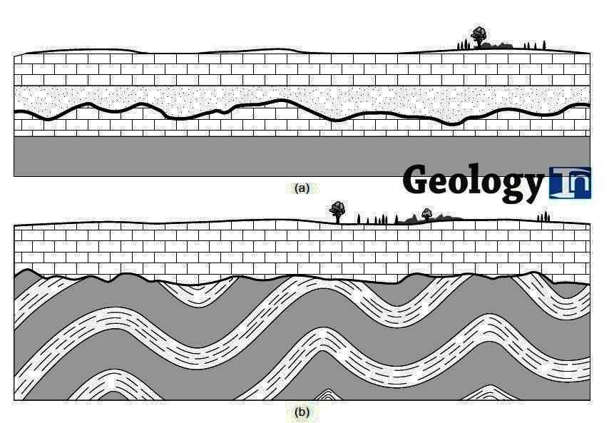
Figure 1 – The Principal Types of Unconformities: (a) Disconformity, (b) Angular Unconformity
Image from geologyin.com
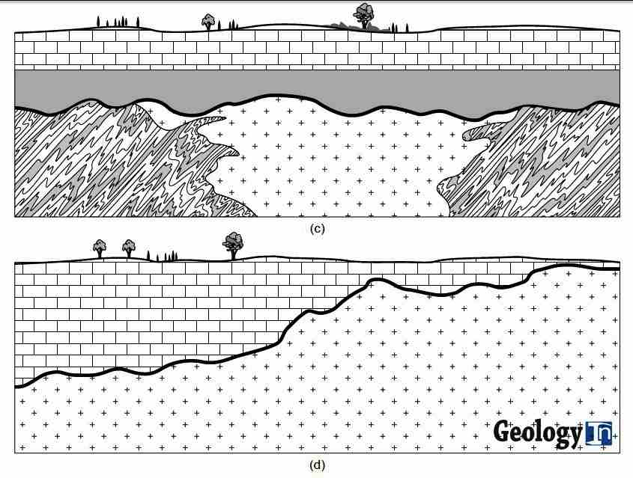
Figure 2 – The Principal Types of Unconformities: (c) Nonconformity, (d) Buttress Unconformity
Image from geologyin.com
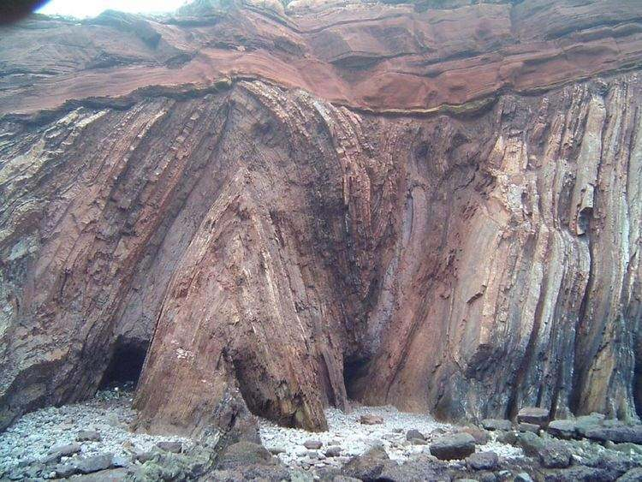
Example of an Angular Unconformity – the rock formation above shows an angular unconformity found on the coast of Portugal at Telheiro Beach
Image copyright by Gabriel Gutierrez-Alonso from geologyin.com
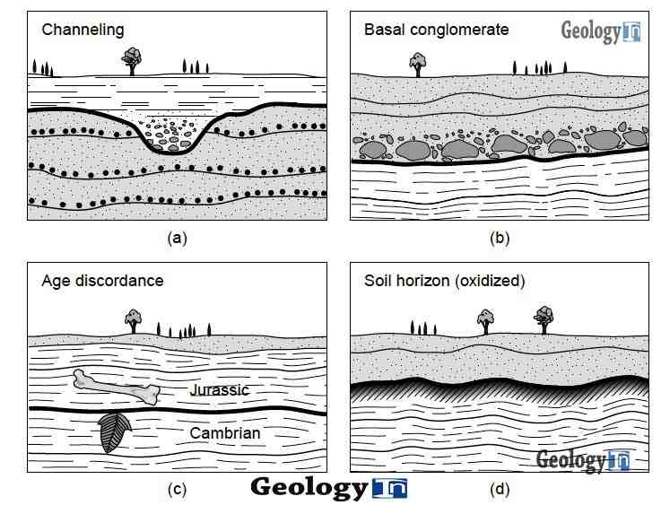
Figure 3 - Some Features Used to Identify Unconformities: (a) Scour Channels in Sediments,(b) Basal Conglomerate, (c) Age Discordance From Fossil Evidence, and (d) Soil Horizon or Paleosol
Image from geologyin.com
Unconformities represent gaps in the rock record that can range in duration from thousands of years to billions of years. Examples of great unconformities, representing millions or billions of years, occur in the Canadian shield, where Pleistocene till buries Proterozoic and Archean gneisses
Commonly, an unconformity may be marked by a surface of erosion, as indicated by scouring features, or by a paleosol, which is a soil horizon that formed from weathering before deposition of the overlying sequence. Some unconformities are marked by the occurrence of a basal conglomerate, which contains clasts of the rocks under the unconformity. Unconformable contacts are generally referred to as unconformities, and the gap in time is represented by the unconformity (that is, the difference in age between the base of the strata above the unconformity and the top of the unit below the unconformity) which is called a hiatus.
To convey a meaningful description of a specific unconformity, geologists distinguish among four types of unconformities that are schematically shown in the above Figures 1, 2, and 3; and are defined below.
At a disconformity, beds of the rock sequence above and below the unconformity are parallel to one another, but there is a measurable age difference between the two sequences. The disconformity surface represents a period of nondeposition and/or erosion. (See Figure 1 (a).)
At an angular unconformity, strata below the unconformity have a different attitude than strata above the unconformity. Beds below the unconformity are truncated at the unconformity, while beds above the unconformity roughly parallel the unconformity surface. Therefore, if the unconformity is tilted, the overlying strata are tilted by the same amount. Because of the angular discordance at angular unconformities, they are quite easy to recognize in the field. Their occurrence means that the sub-unconformity strata were deformed (tilted or folded) and then were truncated by erosion before deposition of the rocks above the unconformity. Therefore, angular unconformities are indicative of a period of active tectonism. If the beds below the unconformity are folded, then the angle of discordance between the super- and sub-unconformity strata will change with location, and there may be outcrops at which the two sequences are coincidentally parallel. (See Figure 1 (b).)
Nonconformity is used for unconformities at which strata were deposited on a basement of older crystalline rocks. The crystalline rocks may be either plutonic or metamorphic. For example, the unconformity between the Cambrian strata and the Precambrian basement in the Grand Canyon is a nonconformity. (See Figure 2 (c).)
A buttress unconformity (also called onlap unconformity) occurs where beds of the younger sequence were deposited in a region of significant pre-depositional topography. Imagine a shallow sea in which there are islands composed of older bedrock. When sedimentation occurs in this sea, the new horizontal layers of strata terminate at the margins of the island. Eventually, as the sea rises, the islands are buried by sediment. But along the margins of the island, the sedimentary layers appear to be truncated by the unconformity. Rocks below the unconformity may or may not parallel the unconformity, depending on the pre-unconformity structure. Note that a buttress unconformity differs from an angular unconformity in that the younger layers are truncated at the unconformity surface. (See Figure 2 (d).)
The Great Unconformity, as previously mentioned, is visible in the Grand Canyon at the base of a rock cliff above where the canyon walls slope down to the Colorado River. The flat-lying layered sedimentary rocks of the 525-million-year-old Cambrian Tapeats Sandstone rest on metamorphic rocks of the 1,740-million-year-old Vishnu Schist.
The results of this Cambrian explosion of sediments occurring during this span are well documented in the fossil record, but its cause — why and when it happened, and perhaps why nothing similar has happened since — has been a mystery.
“The Great Unconformity is a very prominent geomorphic surface and there’s nothing else like it in the entire rock record,” says Shanan Peters, a geoscience professor at the University of Wisconsin–Madison who led some new work. Occurring worldwide, the Great Unconformity juxtaposes old rocks, formed billions of years ago deep within the Earth’s crust, with relatively young Cambrian sedimentary rock formed from deposits left by shallow ancient seas that covered the continents just a half billion years ago.
But Peters says the gap itself — the missing time in the geologic record — may hold the key to understanding what happened. In an issue of the journal Nature, she and colleague Robert Gaines of Pomona College reports that the same geological forces that formed the Great Unconformity may have also provided the impetus for the burst of biodiversity during the early Cambrian.
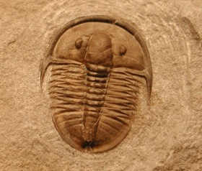
A Cambrian Trilobite, with a Shell Made of Calcium Carbonate
Photo: Shanan Peters
“The magnitude of the unconformity is without rival in the rock record,” Gaines says. “When we pieced that together, we realized that its formation must have had profound implications for ocean chemistry at the time when complex life was just proliferating.”
“We’re proposing a triggering mechanism for the Cambrian explosion,” says Shanan Peters. “We hypothesize that biomineralization evolved as a biogeochemical response to an increased influx of continental weathering products during the last stages in the formation of the Great Unconformity.” Peters and Gaines looked at data from more than 20,000 rock samples from across North America and found multiple clues, such as unusual mineral deposits with distinct geochemistry, that point to a link between the physical, chemical, and biological effects.
During the early Cambrian, shallow seas repeatedly advanced and retreated across the North American continent, gradually eroding surface rock to uncover fresh basement rock from within the crust. Exposed to the surface environment for the first time, those crustal rocks reacted with air and water in a chemical weathering process that released ions such as calcium, iron, potassium, and silica into the oceans, changing the seawater chemistry. The basement rocks were later covered with sedimentary deposits from those Cambrian seas, creating the boundary now recognized as the Great Unconformity.
Evidence of changes in the seawater chemistry is captured in the rock record by high rates of carbonate mineral formation early in the Cambrian, as well as the occurrence of extensive beds of glauconite and potassium-, silica-, and iron-rich mineral that is much rarer today.
The article by Peters and Gaines shows the interaction between the geosphere and biosphere for creating new organisms in the seas and the new rapidly eroded minerals and their resulting chemical reactions in the oceans. The sediment layers of limestone and sandstone directly above the GU interface give evidence of the earliest multi-cellular organisms, the first fauna of worms, and attest to the proposed interaction. But the process of this layering would have a hiatus of 900 to 1000 million years because of a proposed thick ice sheet on the landmasses.
The Granite Problem
The so-called “granite problem” labeled by geologists occurs because granite’s composition, physical distribution, rock cycle, and shapes are not well explained or are indeed mysterious. The missing link is that a large impactor struck and penetrated deeply into the Earth’s mantle. The typical molten mantle as it cools creates lava that cools into basaltic igneous rock. But granite, which is at the base of every continental crust, exposes itself at the backbone of each continent called ancient cratons. This granite also is pushed upward at tectonic boundaries making the cores of mountains. The impactor’s majority of volatile, lighter materials mixed with Earth’s mantle producing a less dense igneous rock having more silicates than basaltic rocks. This intrusive rock formed deep under the crust due to certain necessary pressures and temperatures and was left to cool slowly. For large impacts, the energy turns into heat that melts and vaporizes rocks. If a big enough hole is made, there will be extensive metamorphic changes to deep rocks due to the pressure release of removing kilometers of rock. In the special case of a moon-sized impactor, the mantle not only sees metamorphic changes but is displaced and discharged outwardly. Eventually, the melted impactor material mixes with the mantle, and this new version of material moves upward to fill the impact crater and possibly overflows its rim formed by the collision. The initial impact crater formation perhaps looked like the schematic model below except the scale is on global dimensions.
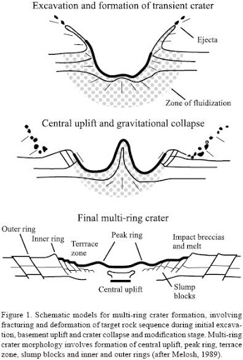
Schematic Model for Multi-Ring Crater Formation – Multi-ring crater morphology involves the formation of central uplift, peak ring, terrace zone, slumping blocks, and inner and outer rings
Image from scielo.org.mx
The consensus theory is while early Earth's undersea surface was made entirely of dark, heavy volcanic rock called basalt, over time, a lighter kind of rock formed. This rock, called granite, was buoyant. It floated up from the ocean floor and gathered into thick layers, creating landmasses that we call continents. Problems with this theory are immediately apparent and addressed. If granite is an older rock due to its plutonic, slow crystallizing nature, how did it emerge above the much earlier solidified basalt of the oceanic crust? And if it emerged via diapirs then how did it flow into thick layer upon layer on top of the lithosphere to form a granitic continental crust? Granite’s flow characteristics are sluggish compared with basalt. If granite formed under the lithosphere, then it could not crystallize due to the hotter thermal gradient of the mantle. And why did these particular minerals gather into one hemispheric location, a mega-continental crust, the area of only ¼ of the globe’s surface?
Geologists claim that granite has a “space problem.” Granite magma averaging 10 km under other rocks cannot push the surface upward creating large plutons, many being an oval shape. Sedimentary rocks that are melted cool into granite, but their rapid cooling produces denser basalt or obsidian rock. The basic questions become: How do large areas and volumes of exposed intrusive granite form? How does the molten rock get there and where has all the rock that evacuated the space go?
There is a range of structures of deeply embedded magma near the surface ranging from sills, dykes, laccoliths, and ringlike formations that are associated with intrusive granite at shallow depths. But typically large areas of granite are found at greater depth with no available force to push other rock away. Such magmas were first thought to ascend via diapirs and then balloon into large chambers. But geologists have proven that granite diapirs will cool and freeze long before they could produce such voluminous chambers. It was thought for some time granite diapirs were similar to large salt deposits. It is known in some sedimentary basins that thick layers of salt become unstable and rise towards the surface as a blob-like diapir or like wax in a lava lamp.
Granite is too sticky to flow through dikes or sills the way basaltic magma does. The lava of granite flows very slowly and tends to get stuck in volcanoes which eventually explode. Recently discovered is that granite magma easily flows upward into vertical cracks for small volumes. The new thinking is that large areas of granite on the surface are the assembly of small batches that matches the record of surface vulcanism. Only in the hotter middle crust do small batches move upward as more granite arrives. Where does this granite come from? It comes from much deeper in the crust, but why? The modern model develops where the lower crust is made of a series of pancake-like formations that intersect two sets of structures. One is related to contemporary plate tectonic movements and the other from pre-existing batholiths. The questions remain as to where these intrusive batholiths of granite came from and how were they made. The only answer is that a penetrating impactor created this phenomenon
Authors, R. Perrin and M. Roubault, in their article, On the Granite Problem, in The Journal of Geology express the following anomalies in studying granite. These problems are: in the order of crystallization, the inadequacy of hypothetical aqueous residual and "pore" liquids, the complexities and inconsistencies of the theories of differentiation, the insurmountable problem of granite emplacement (the "space problem"), the problem of the gneissic zones and the gradation of gneiss into granite, are all taken as evidence that the theory for granite as a product of crystallization of normal magma is strangely inadequate. These researchers have no clue that the beginnings of granite plutons, as proposed, started from the bottom and moved upward over large periods of time.
The eruptive character of granite dikes is an anthropomorphic or subjective idea. Conclusive evidence that some granite dikes are replacement phenomena is proven. However, it is truly not known whether the conditions are the same as for granite plutons found deep within the crust. Though some researchers admit granite to be polygenetic, it seems more probable that such a singular rock should be of one mode of origin, namely, diffusion and metasomatism in the solid state. Metasomatism is the chemical alteration of a rock by hydrothermal and other fluid processes. It is the replacement of one rock by another of different mineralogical and chemical compositions. The minerals which compose the rocks are dissolved and new mineral formations are deposited in their place. What mysterious process tends to transform a sedimentary rock into the final product which is always the same, granite or granodiorite? There is none. Sedimentary rock becomes metamorphic or returns to magma to later become igneous once more, but never achieves the parameters needed for plutonic granite.
Granite and granodiorite rocks are both classified as granitic because they both are rich in quartz. Granite contains mostly potassium feldspars and has a low percentage of dark iron and magnesium minerals. In contrast, granodiorite contains more plagioclase (calcium and sodium) feldspar than potassium feldspar and has more dark minerals. Granodiorite is a plutonic igneous rock, formed by an intrusion of silica-rich magma, which cools in batholiths or stocks below the Earth's surface. It is usually only exposed at the surface after uplift and erosion have occurred.
Granite magmas are much more viscous than mafic magmas and are more homogeneous in composition. This homogeneity is caused by the viscosity being orders of magnitude higher than mafic magmas. The granitic magma tends to move in a larger concerted mass and be emplaced as a larger mass because it is less fluid and less able to move. This is the reason why granites tend to occur in large plutons and mafic rocks in dikes and sills. Granite magmas are cooler and less able to melt adjacent country rocks. Contamination is therefore minor and unusual. Because mafic magmas are more fluid, crystal precipitation occurs more rapidly resulting in greater fractional crystallization. Higher temperatures also allow mafic magma to assimilate wall rocks more readily, therefore, making contamination more common.

Some interesting examples are shown of granite plutons that reached the surface.
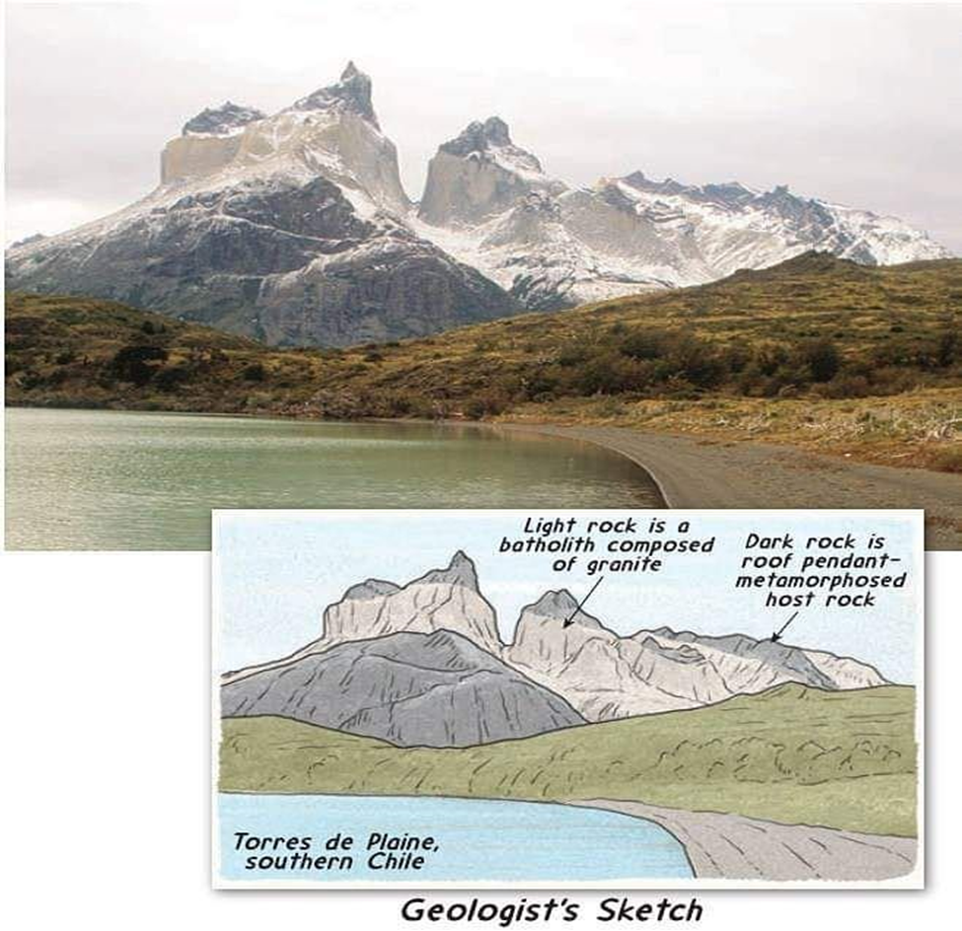
Batholith of Granite at Torres del Paine in southern Chile
Image from Pinterest
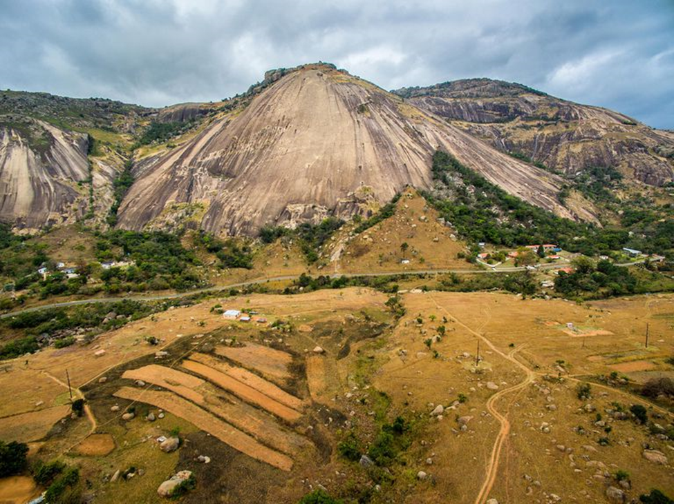
Plutons
Image from thoughtco.com
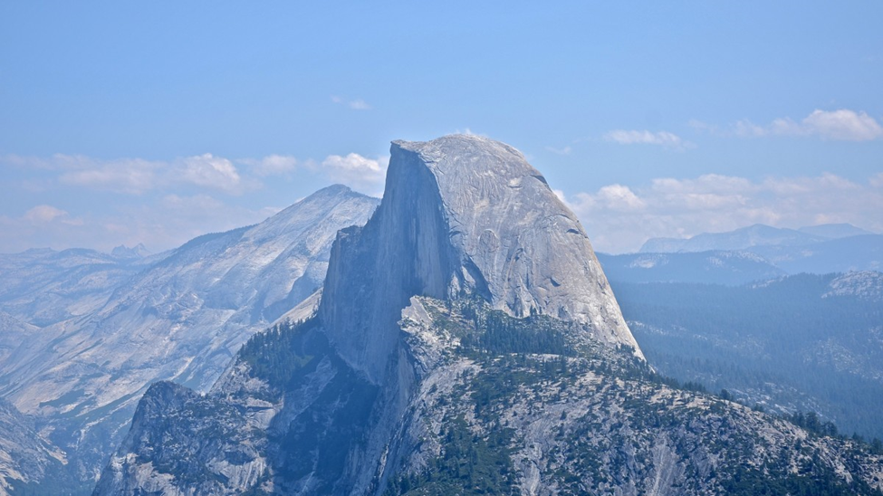
Batholith of Granite, Half Dome at Yosemite
Image from wikipedia.org
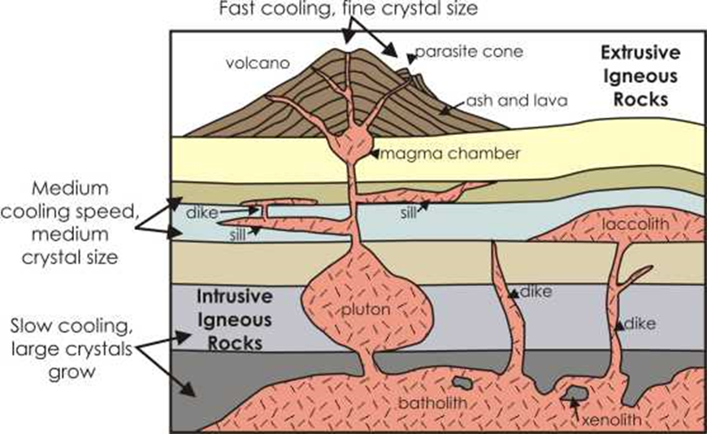
Granite Pluton Locations
Image from www.geocaching.com/geocache/GC20DTB_mpakenis-granite-pluton
The above cross-sectional diagram shows the locations of slow cooling intrusive granite and faster cooling extrusive granites. These deeper granite rocks are eventually raised to a temperature/pressure regime making crystallization possible and then become exposed to the surface due to the wasting of the above softer rocks.
The mysterious process or force aforementioned is the effect of Earth’s impactor injecting different materials into the heart of its mantle. This force creates the mixing and deep burial of lighter materials of more silicates, water, and other lighter minerals found in the igneous rocks of the continental crusts. These lighter materials, due to the pressures of gravity, sought higher levels in the crust and are squeezed via diffusion and metasomatism to create different minerals and rocks such as plutonic granite. This type of granite never entered the rock cycle identified by geologists but emerged from the mid and even lower levels of the mantle to finally come to rest at the base of the continental crust. In the pristine Earth without such an impactor no intrusive granite would have formed. Most of all granite before the great impactor differentiated to the surface to create an extrusive basaltic-type granite. Intrusive granites finally pushed upward under the extremely higher-grade metamorphic rocks such as schist and gneiss and were exposed by the uplifting of plate tectonics and millions of years of wasting of rocks on top. Their eventual exposure marked the cores of the oldest rocks on each sub-continent after the mega-continent split apart. Plutonic granite is the last crystallization stage for the continental crusts.
The following dissertation concerning the formation of granite by the Geological Society is quoted. “All igneous magmas contain dissolved gases (water, carbonic acid, hydrogen sulfide, chlorine, fluorine, boric acid, etc.). Of these water is the principal, and was formerly believed to have percolated downwards from the Earth’s surface to the heated rocks below, but is now generally admitted to be an integral part of the magma. My comment is that water cannot be forced to the known depths of granite plutons because the pressures and temperatures physically do not allow it. All water and other gases should have raised to the surface through gravitational pressures in the original differentiation. Many peculiarities of the structure of the plutonic rocks as contrasted with the lavas may reasonably be accounted for by the operation of these gases, which were unable to escape as the deep-seated masses slowly cooled, while they were promptly given up by the superficial effusions. My immediate question becomes: How did these gases remain at these depths without being properly differentiated and evacuated? There are no physical reasons given. The plutonic or intrusive rocks have never been reproduced by laboratory experiments, and the only successful attempts to obtain their minerals artificially have been those in which special provision was made for the retention of the “mineralizing” gases in the crucibles or sealed tubes employed. These gases often do not enter into the composition of the rock-forming minerals, for most of these are free from water, carbonic acid, etc. Hence as crystallization goes on, the residual melt must contain an ever-increasing proportion of volatile constituents. It is conceivable that in the final stages the still uncrystallized part of the magma has more resemblance to a solution of mineral matter in superheated steam than to a dry igneous fusion. My specific point is that due to unknown powerful forces, water that was infused and trapped by the proposed Earth’s impactor took on an unknown super-phase that cannot be reproduced experimentally. Quartz, for example, is the last mineral to form in granite. It bears much of the stamp of the quartz which we know has been deposited from aqueous solution in veins, etc. It is at the same time the most infusible of all the common minerals of rocks. Its late formation shows that in this case, it arose at comparatively low temperatures and points clearly to the special importance of the gases of the magma as determining the sequence of crystallization.” When solidification is nearly complete the gases are no longer retained in the rock and escape through fissures towards the surface. These gases are important in creating adjacent gneiss rock and the deposition of quartz veins.
Water is required to form quartz and feldspar in the granite that must either diffuse or disappear without producing the slightest distortion of the rocks by volume changes. The granitic plutons must have lost their water origins, despite the very high pressures and temperatures that lessened as the granitic plutons came to the surface. It is known that water can only be forced so deep before it is resisted by the isostatic pressures encountered long before achieving the known depth of granite plutons. How did the water and other lighter liquid volatiles find their way to such unbelievable crustal depths? Yes, there is a “granite water problem”. The high energy of a deeply penetrating impactor of frozen volatiles, including water, can achieve such depths when the original mega-continent was made. These volatiles were squeezed upward over time and cooled, enough silicates and other minerals diffused and metasomatized with water to form plutons of granite. These granite plutons would then form the basement rock for the individual continental crusts that mostly solidified about 2.0 to 1.6 billion years ago (bya). Necessary cooling to form plutonic granite took an estimated 1.9 billion years from 3.9 bya to 2.0 bya due to residual heat from both the impactor’s kinetic energy and Earth’s early hot mantle. Radioactive heating was also a factor.
Granite is thought to be the oldest igneous rock in the world, believed to have been formed 300 million years ago. The ingredients for granite were brought by the impactor and mixed with the basaltic ingredients of the original mantle. It consists of coarse grains of quartz (10-50%), potassium feldspar, and sodium feldspar. These minerals make up more than 80% of the rock. Other common minerals include mica (muscovite and biotite) and hornblende. Much of the Earth's continental crust is made of granite, and it forms the cores of the continents. In North America, the landscape surrounding Canada's Hudson Bay and extending south to Minnesota consists of shallow granite bedrock.
The difference between granites and basalts is in silica content and their rates of cooling. A basalt is about 53% SiO₂, whereas granite is 73%. Also, the granite is stickier and flows more slowly than basalt, and has less chance of forming volcanoes. Granite is an intrusive igneous rock that forms from molten material or magma that flows and solidifies underground, where the magma cools slowly. Eventually, the overlying rocks are removed, exposing the granite. Volcanic rocks are mostly basalt and obsidian. Plutonic granite that finds a molten lava chamber and erupts to the surface via a volcano cools quickly and is known as rhyolite. The difference between granite and rhyolite is told by its cooling rate. The much slower cooling rate of deep plutonic rock permits the growth of large mineral crystals which can be easily seen by the unaided eye. Granite is a heterogeneous mixture made of various minerals containing different chemical compositions expected from a cataclysmic explosion and intense diffusion caused by a gigantic impact.
Calculations show that known volumes of granite magma would take several millions of years to cool down from 900 degrees C to near 550-650 degrees C, where it would completely crystallize, and then finally cool to 25 degrees C temperature found at the Earth's surface. However, the initial temperature at post-impact was much higher than 900 degrees C. When granite is subjected to intense heat and pressure, it changes into a metamorphic rock called gneiss. The gradation of gneiss into granite is a mystery because it forms by higher temperature and pressure but never transforms to granite. Plutonic granite does not come from the original mantle and is not pristine or indigenous like the basaltic granite; otherwise, it would have mixed and differentiated at the same time. Plutonic granite could only have followed an unusual event such as the postulated penetrating impactor. Plutonic granite was never part of the rock cycle until much later in the life of the continental crusts when tectonic plate uplifts began to expose it to the surface. Only then could erosive and metamorphic processes affect its structure. So deeply embedded in the crust, plutonic granite became the remnant cores of all the continents and the oldest rocks on the planet.
The beginning of the rock cycle was caused by wasting making sedimentary rocks and tectonic plates shift and move under the Earth’s surface to make metamorphic rocks or return the rock to hot magma to later become renewed igneous rock. Granite's so-called problem is that it never entered the rock cycle. When eventually returned to magma, granite never was reproduced. Granite is the remaining remnant of all ancient rocks that crystallized after the great impact caused a caldera to raise above the primeval ocean and its basaltic crust. Granite plutons were produced throughout the mega-continent boundary. The central or inner parts of these granitic crusts were protected by riding at the bottom of the wasted topmost crust which was further protected by being on top of and central to the lithospheric plates.
The hypothesis for plutonic granite is a special case of a deeply impacted frozen rogue planet injecting new materials into the central mantle of Earth about 3.9 billion years ago. This case can be further corroborated by briefly reviewing the rock cycle.
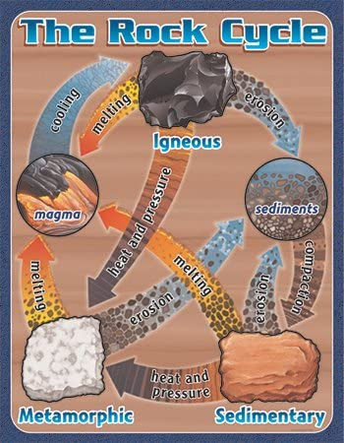
The Rock Cycle
Image from clipart-library.com/clipart/2034320.htm
As shown in the following diagrams there are three principal ways rock behavior crosses to the right of the green solidus line to create molten magma: 1) decompression melting caused by lowering the pressure, 2) flux melting caused by adding volatiles, and 3) heat-induced melting caused by increasing the temperature.
The four Pressure-Temperature (P-T) diagrams show the temperature in degrees Celsius on the x-axis and depth below the surface in kilometers (km) on the y-axis. The red line is the geothermal gradient and the green solidus line represents the temperature and pressure regime at which melting begins. Each of the four P-T diagrams is associated with a tectonic setting as shown by a side-view (cross-section) of the lithosphere and mantle.
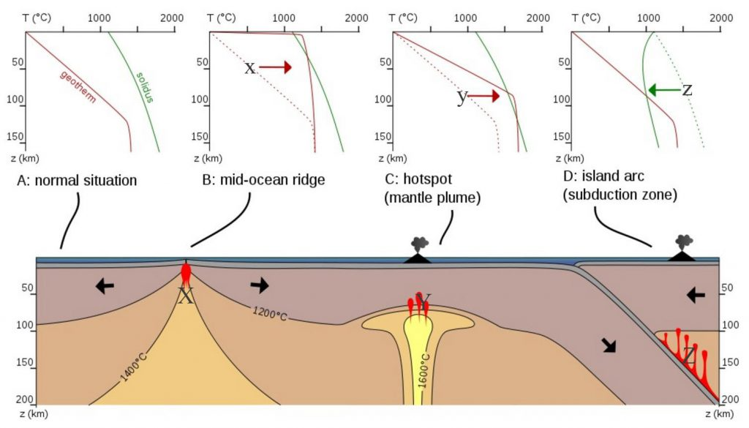
Pressure/Temperature Diagram of Partial Melting
Image from wikipedia.org
When tectonic plates under the Earth's surface shift, they create space between them. Hot rock under these plates then rises to occupy the space. As the rock rises, the pressure placed on the rock decreases and causes the rock to melt – a process called decompression.
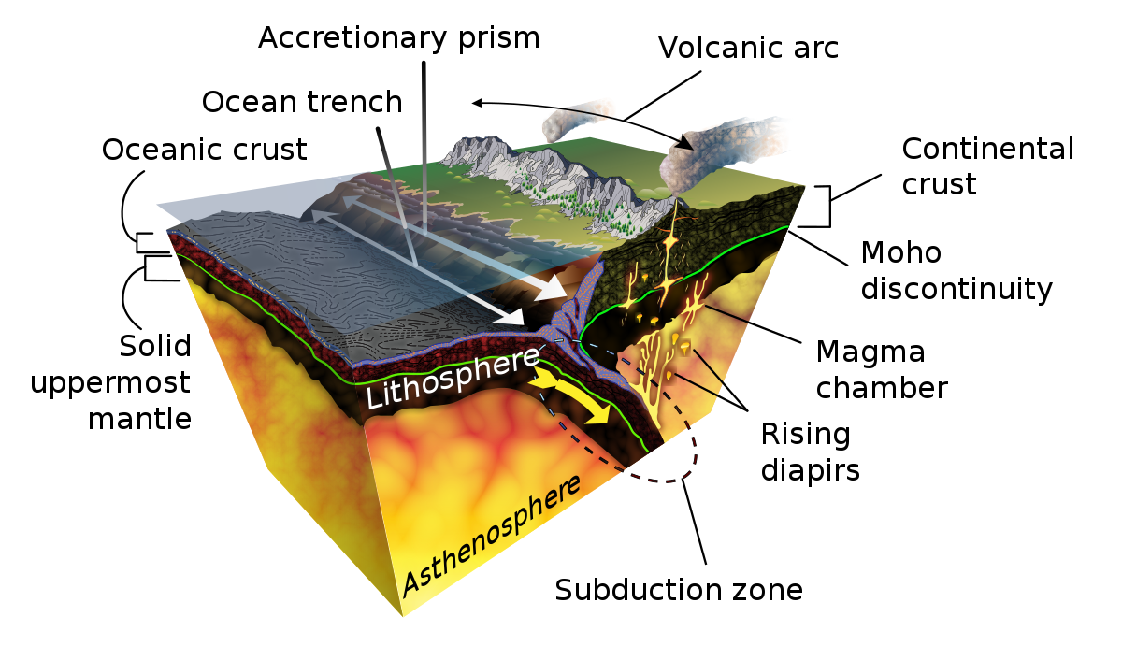
Plate Tectonic Subduction
Image from wikipedia.org, Subduction
Change occurs to maintain equilibrium conditions with new states of heat, pressure, or fluids. Thus, major changes in any of these three environmental variables can result in metamorphism. Because of the great conveyor belt of plate tectonics, rocks can encounter a variety of environmental conditions riding around in pressure, temperature, and fluid space. As these rocks go, they may metamorphose and may have a tale to tell of where they've been. The fingerprints of metamorphism are the growth of new minerals stable at the new PTF conditions and changes in texture reflecting the state of stress.
The temperature in the Earth goes up with depth. Near the surface of the ordinary crust, the temperature rises some 30 degrees per kilometer. This is partly due to radioactive decay within the crust, but also comes from the fact that the Earth is still very hot from its initial formation (recall that the core is largely molten iron). So if rocks are taken from the surface "down the tubes" either by burial or on a lithospheric nose dive, they will heat up and metamorphose.
Pressure changes with depth in the Earth as a result of the increased weight of the overlying rock. Increased pressure drives minerals to form more compact phases, driving for example coal to change into diamonds, and clay to rubies. Pressure also changes the state of stress. Crystals will grow or deform by cracking or flowing in response to the change in stress and show either preferential alignment, or evidence of squashing that reflects in some way the stress regime of the new environment
Changes in the chemistry of the fluids in the pore spaces of rocks also induce change. One common cause of changes in the fluid chemistry is the proximity of something hot - take volcanic activity for example. The heat induces convection currents in the surrounding fluids. The heated water reacts locally with the hot rock and carries a load of dissolved matter (rich in metals and sulfur) from the region of high heat into a region of cooler rock. Here, the fluids tend to "release their load heat energy". This form of metamorphism is known as hydrothermal alteration and is the way most metallic ore bodies are formed. When the super-charged fluids come out of brand-new ocean crust and hit 2° C water, they drop their load and form what is known as a black smoker. Lots of animals or microbes are known to live off this stuff.
Metamorphism means to change form. In the geologist's sense, it refers to changes in rocks in the solid-state but not by melting the rock wholesale. The diving rocks from subduction take water with them. Due to the increasing pressures and temperatures the deeper one goes does not permit water to go to depths where plutonic granite is thought to form. Also, intrusive granite requires millions of years to slowly crystallize. The tectonic movements during the continental drift of the Pangaea era of the past 250 million years do not allow enough time for this process.
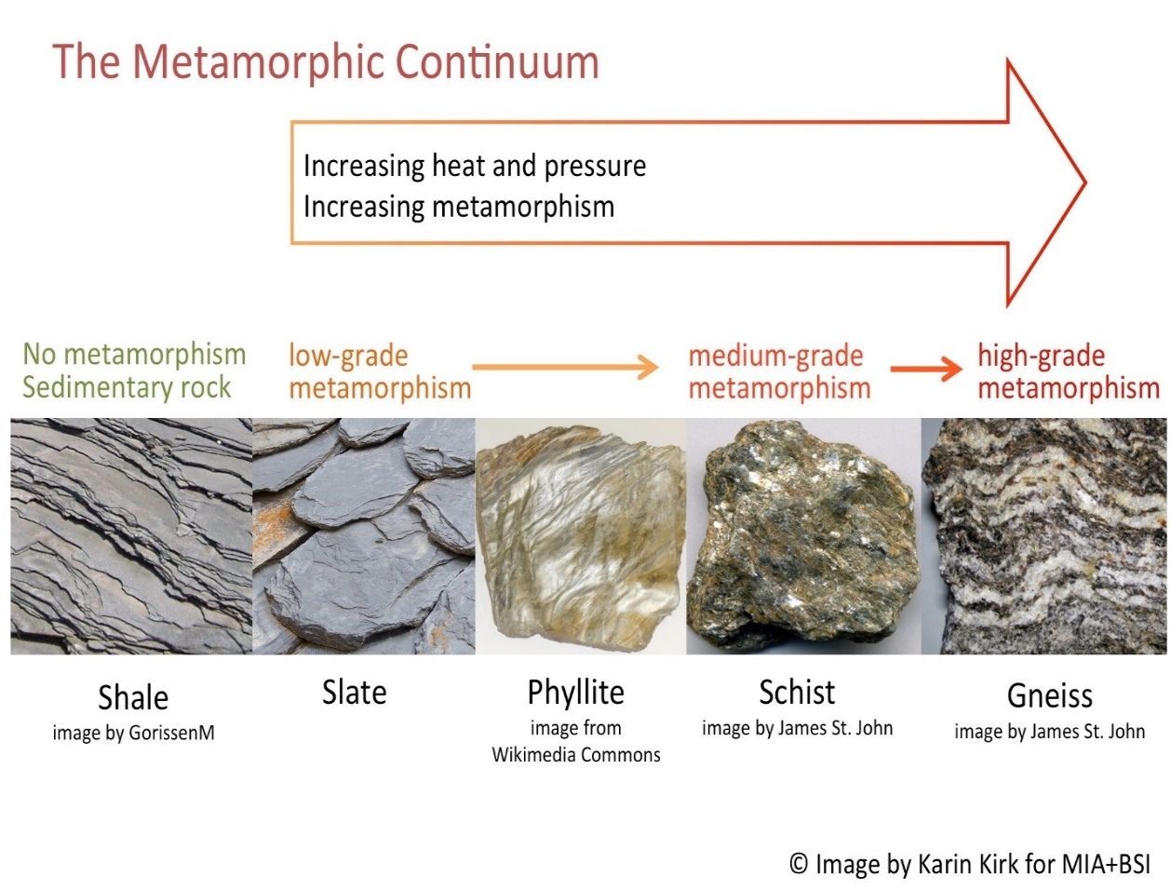
Shown above are examples of metamorphic rock that result from a combination of increased temperature and pressure. Generalized composition ranges of common igneous rocks are shown below to further demonstrate the rock cycle. Gneiss rock does not convert to intrusive granites and intrusive granites high in silicates such as feldspar and quartz are never re-constituted through such processes as diffusion or metasomatism. These granites can only be created by the exceptional case of Earth’s penetrating impactor shock 3.9 billion years ago.
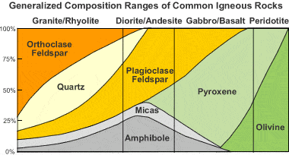
Andesite: Igneous Rock
Image from geology.com, Andesite
Geologists debated for a long time about the origin of granite. They finally agreed that two basic types are the faster cooling extrusive rhyolite and the slowly cooling intrusive granites formed in plutons deep inside the Earth. But a great riddle still stands. The chemical composition of granite differs significantly from what is known about the composition of the Earth’s interior. How could granite possibly form on Earth? It needed the aid of volatiles of an impactor pressed with unbelievable shock into the Earth’s young and less viscous mantle.
The Earth’s Original Atmosphere and the Origin(s) of Our Present Atmosphere – Present-Day Thinking
To fully understand the effect of the first mega-continent and its subsequent breakup into other super-continents a knowledge of the evolution of Earth’s atmosphere is required.
The following-edited lecture is taken from Arizona State University’s geology department. This lecture on the “Origin and Evolution of the Earth’s Atmosphere” is an excellent description and is an easily understandable presentation of Earth’s evolution of its atmosphere but lacks the idea of extra volatiles such as NH₃, CO₂, CH₄, and H₂O being brought to Earth by a frozen rogue planetoid. The thinking of 1) Earth originating at 2.7 AU from the Sun and avoiding the T-Tauri phase of the protosun’s envelope of 1500° F boiling off terrestrial-planet volatiles, and 2) proto-Earth before its major impact having already partially differentiated and formed a crust with ocean and atmosphere - are also not considered.
Our present-day atmosphere (shown first) is very different from the earth's original atmosphere (shown secondly) which was mostly hydrogen and helium with lesser amounts of ammonia and methane.
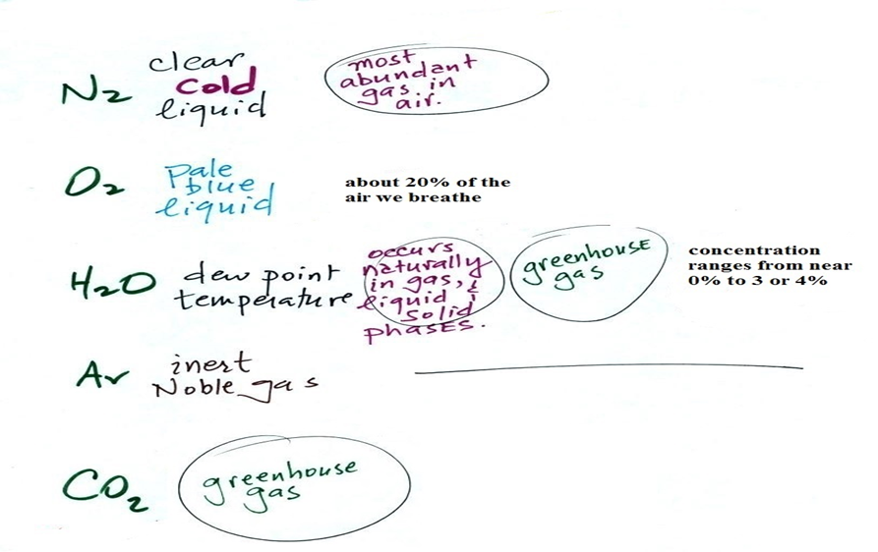
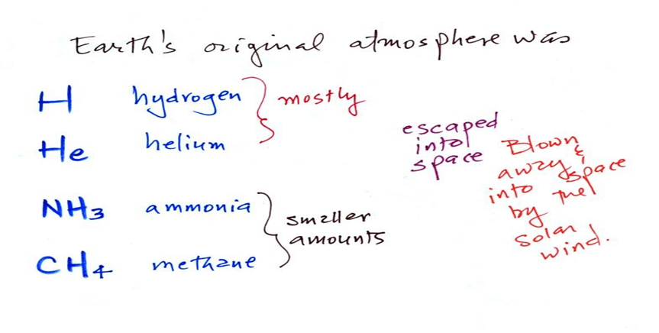
The early atmosphere either escaped into space (the Earth was hot and lightweight gases like hydrogen and helium were moving around with enough speed that they could overcome the pull of the Earth's gravity) or was swept into space by the solar wind.
With the important exception of oxygen (and argon perhaps), most of our present atmosphere is thought to have come from volcanic eruptions. In addition to ash, volcanoes send a lot of water vapor, carbon dioxide, and sulfur dioxide into the atmosphere. Carbon dioxide and water vapor are two of the five main gases in our present atmosphere
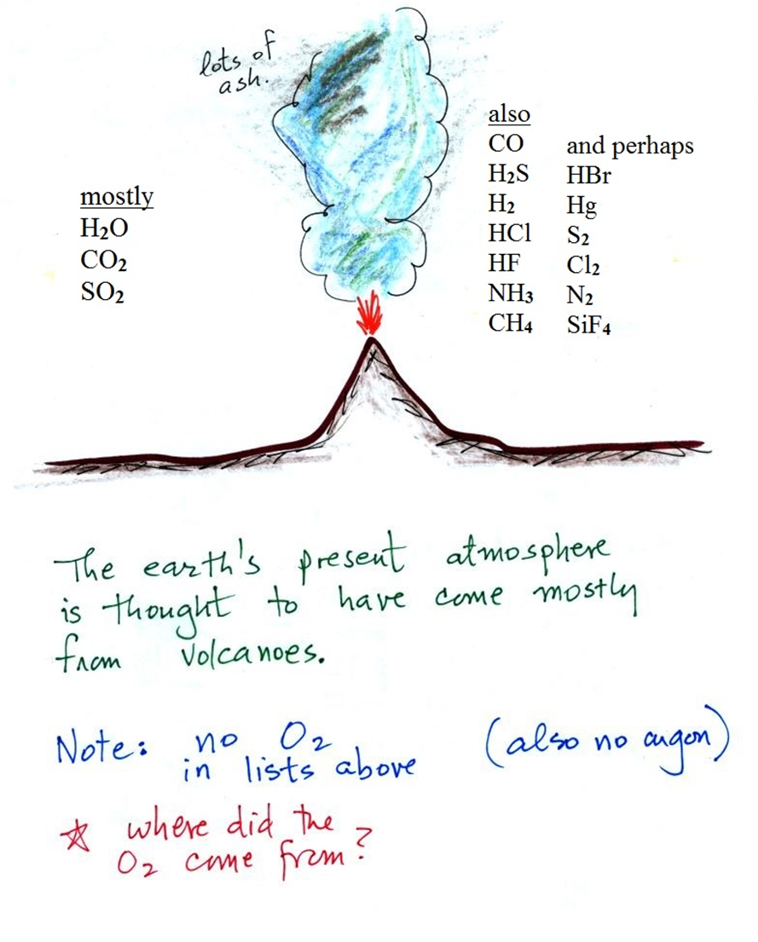
Volcanoes also emit lots of other gases, many of which are very poisonous. Some of them are shown on the right side of the figure. The relative amounts of these "also" and "perhaps" gases seem to depend a lot on volcano type.
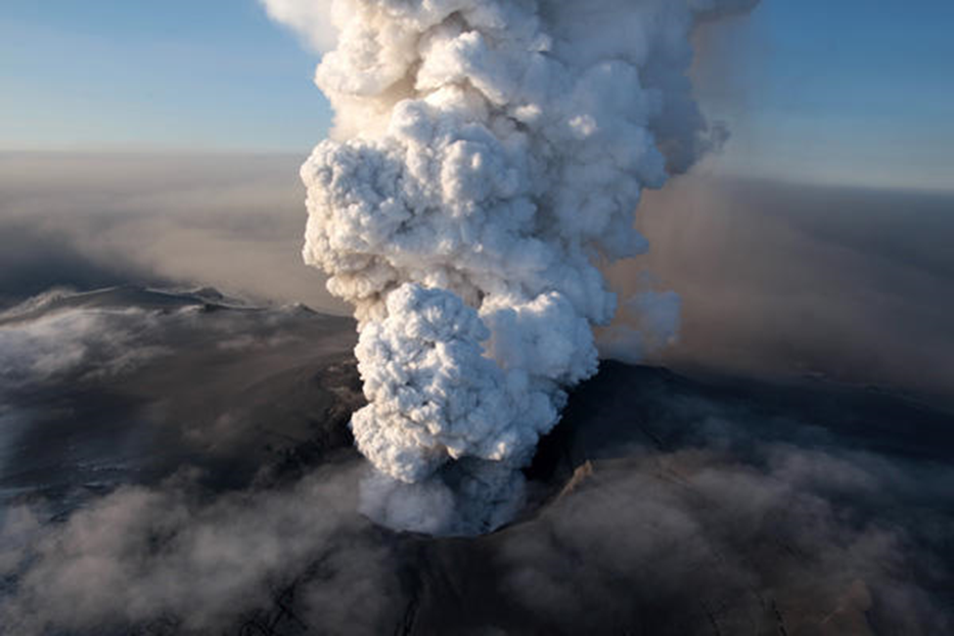
As the Earth began to cool, the water vapor condensed and began to create and fill the Earth's oceans. Carbon dioxide dissolved in the oceans and was slowly turned into rock. Nitrogen-containing compounds like ammonia (NH₃) and molecular nitrogen (N₂) are also emitted by volcanoes. Probably the nitrogen in NH₃ reacted with other gases to produce N₂. Molecular nitrogen is pretty nonreactive so once in the air, its concentration was able to build up over time.
Even more amazing than the photograph of the Icelandic volcano are these photographs of Comet 67P/Churyumov-Gerasimenko taken by the European Space Agency Rosetta spacecraft. The spacecraft was launched on March 2, 2004, and went into orbit around the comet on August 6, 2014. On November 12, the Rosetta spacecraft deployed the Philae lander which successfully landed on the surface of the comet and operated for a brief time. The lander was not able to fully deploy its solar panels and used up its battery power and went into "sleep" mode after about 60 hours of operation. In June this year, the comet had moved into a sunnier part of its orbit and the lander began sending data again. The comet has just reached its perihelion (the shortest distance between the comet and the sun).
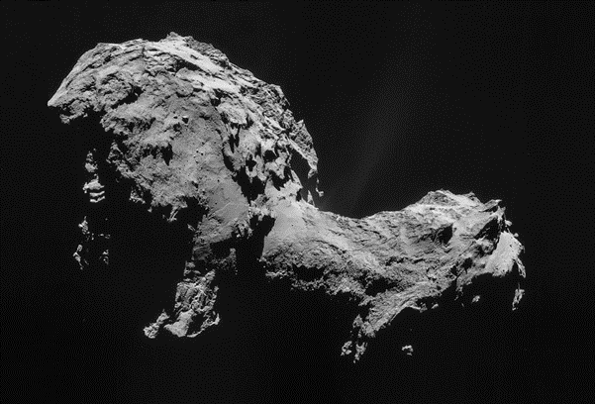
This photograph of the comet is shown because some researchers don't believe that volcanic activity alone would have been able to account for all the water that is on the earth (oceans cover about 2/3 of the earth's surface). They believe that comets and asteroids colliding with the Earth may have brought significant amounts of water. The Rosetta spacecraft has determined that the water on this particular comet differs from the composition of the water in the Earth's oceans. It was reported that "The ratio of deuterium to hydrogen in the water from the comet was determined to be three times that found for terrestrial water." This suggests that comets like 67P were probably not an important source of the Earth's water.
Where did the oxygen in our atmosphere come from?
Oxygen is in H₂O, CO₂, and SO₂ (and many of the other gases emitted by volcanoes) but volcanoes aren't a direct source of the molecular oxygen (O₂) that is present in the air. Where did the O₂ come from? During early times there were two main sources of oxygen.
The first source of atmospheric oxygen:
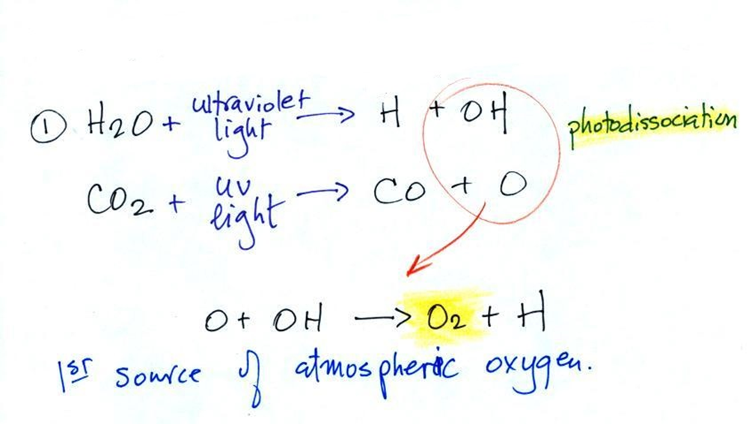
Oxygen is thought to have come from the photo-dissociation of water vapor and carbon dioxide by ultraviolet (UV) light (the high-energy UV light can split the H₂0 and CO₂ molecules into pieces). Two of the pieces, O and OH, then react to form O₂ and H. Ultraviolet rays are a dangerous, high-energy, potentially deadly form of light and it's known that ultraviolet light is capable of breaking molecules apart.
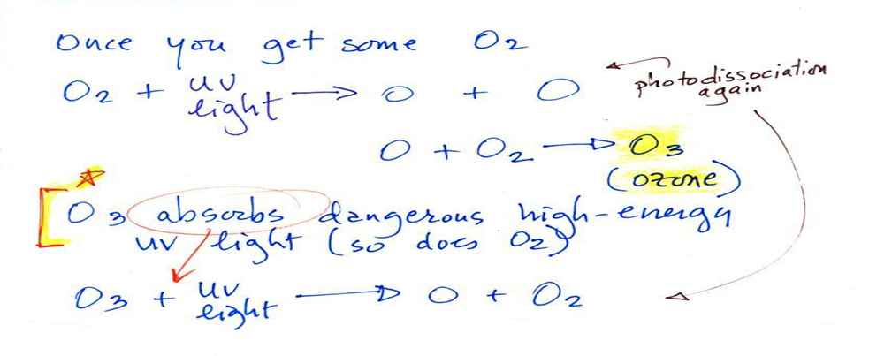
Once molecular oxygen (O₂) begins to accumulate in the air, UV light can split the O₂ apart to make atomic oxygen (O). The atoms of oxygen can react with molecular oxygen to form ozone (O₃).
Ozone in the atmosphere began to absorb the dangerous and deadly forms of ultraviolet light and life forms could then begin to safely move from the oceans onto land (before the buildup of ozone, the ocean water offered protection from UV light). A molecule of O₃ absorbs some UV preventing it from reaching the ground.
O₃ + UV light ---> O₂ + O
You might think the O₂ and O would recombine. But if you picture hitting something with a hammer and breaking it, the pieces usually fly off in different directions. That's essentially what happens with the O and O₂.
A second and more important source of atmospheric oxygen:
Once plant life had developed sufficiently and once plants moved from the oceans onto land, photosynthesis became the main source of atmospheric oxygen.
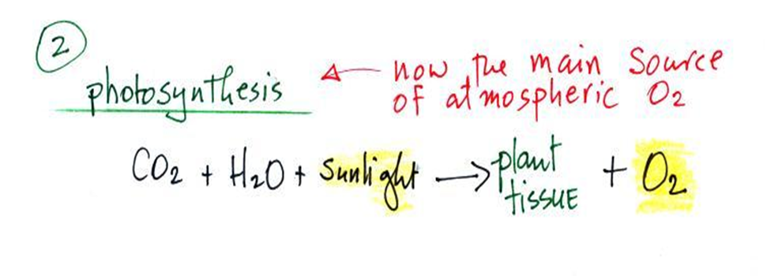
Photosynthesis in its most basic form is shown in the chemical equation above. Plants need water, carbon dioxide, and sunlight to grow. They can turn H₂0 and CO₂ into plant material. Photosynthesis releases oxygen as a by-product.

Combustion is just the opposite of photosynthesis and is shown below.
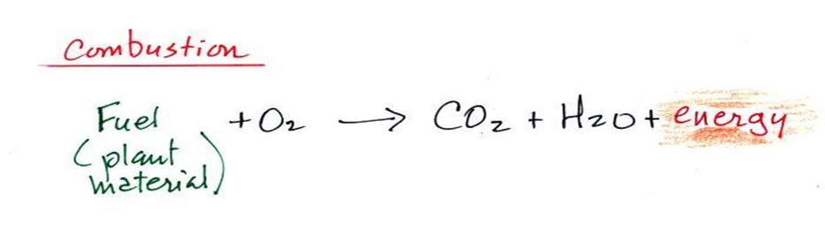
We burn fossil fuels (dead but undecayed plant material) to generate energy. Water vapor and carbon dioxide are by-products. Combustion is a source of CO₂ (photosynthesis is a "sink" for atmospheric CO₂ since it removes CO₂ from the air).
The argon we have in the atmosphere comes from the radioactive decay of potassium in the ground. Three isotopes of potassium occur naturally: potassium-39 and potassium-41 are stable, potassium-40 is radioactive and is the source of the argon in the atmosphere.
Stromatolites, banded iron, and red beds are geological evidence of oxygen on Earth:
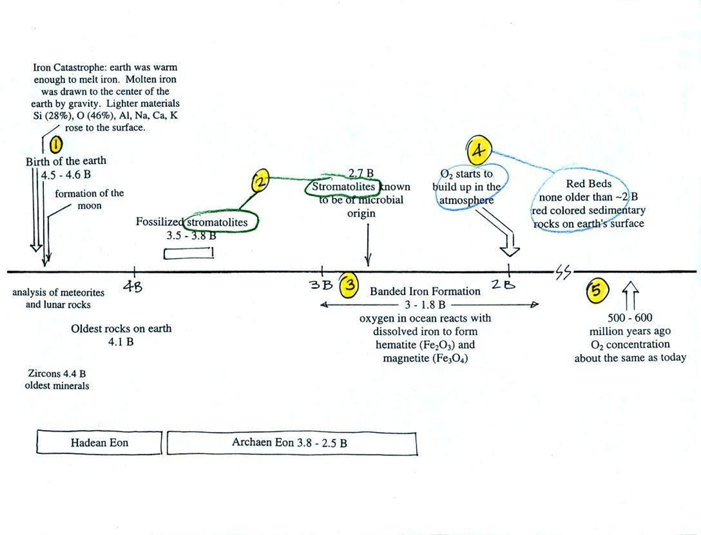
This somewhat confusing figure shows some of the important events in the history of the Earth and the evolution of the atmosphere. There are five main points to take from this figure, and 1-3 are the most important.
First (Point 1), the Earth is thought to be between 4.5 and 4.6 billion years old. If you want to remember the Earth is a few billion years old that is probably close enough. A relatively minor point shown in the figure: the formation of the Earth's molten iron core was important because it gave the Earth a magnetic field. The magnetic field deflects the solar wind and prevents the solar wind from blowing away our present-day atmosphere.
Stromatolites (Point 2) are geological features, column-shaped structures made up of layers of sedimentary rock that are created by micro-organisms living at the top of the stromatolite. Fossils of the very small microbes (cyanobacteria = blue-green algae) have been found in stromatolites as old as 2.7 billion years and are some of the earliest records of life on earth. Much older (3.5 to 3.8 billion-year-old) stromatolites presumably also produced by microbes, but without microbe fossils, have also been found.
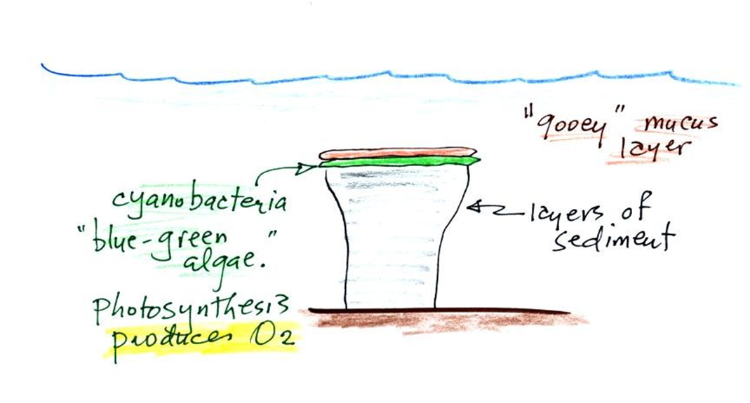
Blue-green algae grow at the top of the column, underwater but near the ocean surface where they can absorb sunlight. As sediments begin to settle and accumulate on top of the algae they start to block the sunlight. The cyanobacteria would then move to the top of this sediment layer and the process would repeat itself. In this way, the stromatolite column would grow layer by layer over time. You might be wondering why we are discussing stromatolites. It's because the cyanobacteria on them were able to produce oxygen using photosynthesis.

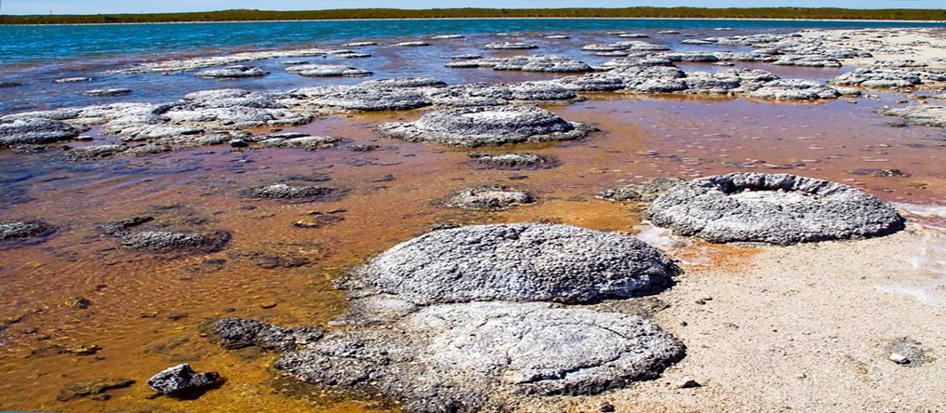
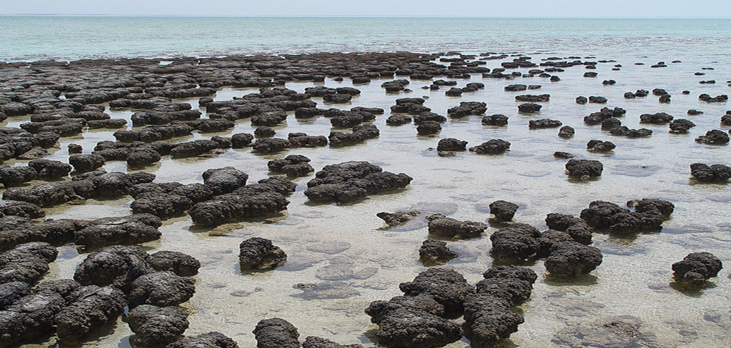
Living stromatolites are found in a few locations today. The two pictures above are from Lake Thetis and Shark Bay in Western Australia. These pictures were probably taken at low tide, the stromatolites would normally be covered with ocean water. It doesn’t look like a good place to go swimming; I would expect the top surfaces of these stromatolites to be slimy. Hamelin Pool in Western Australia is a World Heritage Area, the stromatolites there are the oldest and largest living fossils on Earth.
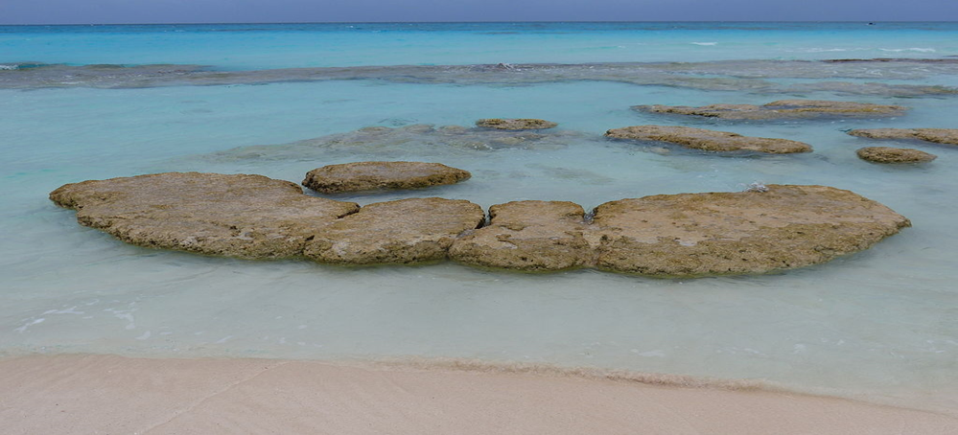
Living Stromatolites at Highborne Cay in the Bahamas
(Point 3) refers to the banded iron formation, a type of rock formation. These rocks are 2-3 billion years old (maybe older) and are evidence of oxygen being produced in the Earth's oceans. Here are a couple of samples of banded iron formation rock.
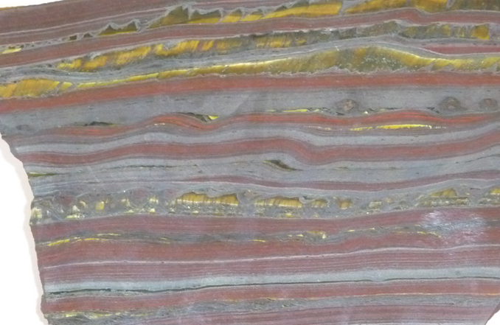
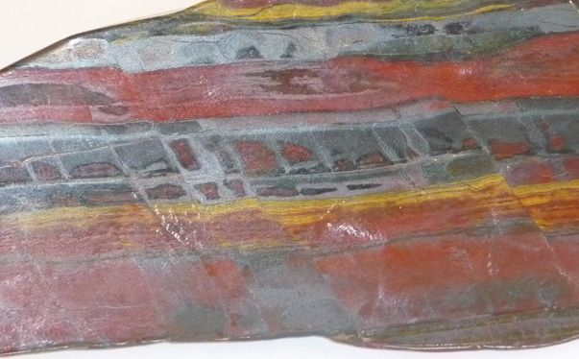
The main thing to notice is the alternating bands of red and black. The rocks are also relatively heavy because they contain a lot of iron. The next paragraph and figure explain how these rocks formed.
Banded iron formation
Rain would first of all wash iron ions from the earth's land surface into the ocean (this was at a time before there was any oxygen in the atmosphere). Once in the ocean, the iron ions reacted with oxygen from the cyanobacteria living in the ocean water to form hematite or magnetite. These two minerals precipitated out of the water to form a layer on the seabed. This is what produced the black layers.
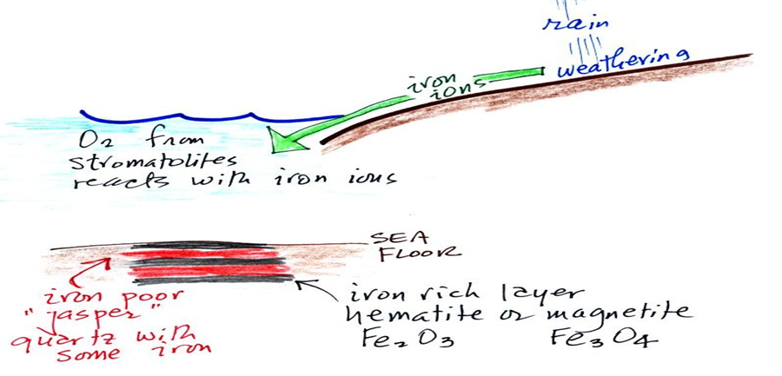
Periodically the oxygen production would decrease or stop (rising oxygen levels might have killed the cyanobacteria or seasonal changes in incoming sunlight might have slowed the photosynthesis). During these times of low oxygen concentration, red layers of jasper would form on the ocean bottom. The jasper doesn’t contain as much iron.
Eventually, the cyanobacteria would recover, would begin producing oxygen again, and a new layer of hematite or magnetite would form. The rocks that resulted, containing alternating layers of black hematite or magnetite and red layers of jasper are known as the banded iron formation.
Eventually, the oxygen in the oceans reacted with all of the iron ions in the water. Oxygen was then free to diffuse from the ocean into the atmosphere. Once in the air, the oxygen could react with iron in sediments on the Earth's surface. This produced red-colored (rust-colored) sedimentary rock. These sediments are called "Red Beds"
(Point 4) None of these so-called red beds are older than about 2 billion years old. Thus, it appears that a real buildup up of oxygen in the atmosphere began around 2 billion years ago.
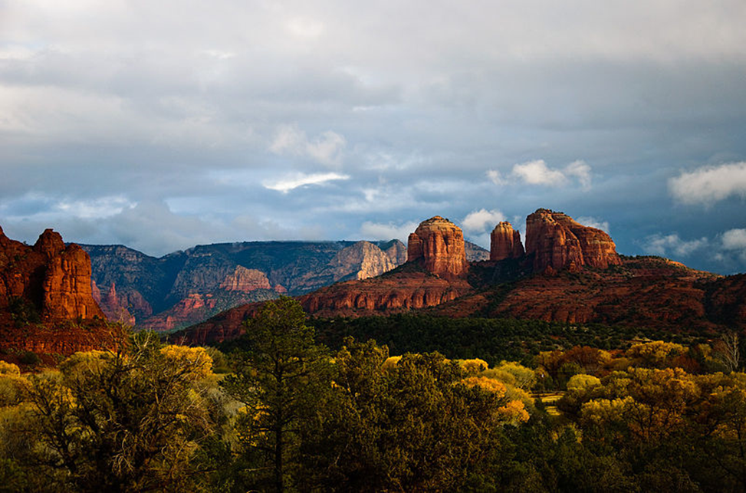
Red Rock State Park near Sedona, Arizona – an example of “red beds” that formed during the Permian period 250-300 million years ago
(Point 5) Oxygen concentrations reached levels that are about the same as today around 500 to 600 million years ago.

The Evolution of the Earth’s Atmosphere Based on This Article’s Viewpoint
For this article, the progression of the atmosphere occurs because of the Earth’s initial orbital location at 2.7 AU, and of delivery of more volatiles by a large impactor. Without these events, Earth could either have been a boring water/ice-covered planet between Mars and Jupiter or lacked an atmosphere similar to the Moon if it was located in its present orbit from the beginning of its formation.
Consensus science’s ideas are listed in roughly chronological order of occurrence. Disagreements with this consensus or paradigms follow and are underlined and italicized.
- At first, there was only hydrogen and helium that quickly burned off because of a very hot atmosphere from the young molten planet Earth and its weak gravity field compared to the outer planets.
- As the Earth cooled, gases spewed from volcanoes having as much as 10 to 200 times CO₂ as today’s atmosphere. Also, H₂S, NH₃, and methane were differentiated from the blob of molten rock and emitted into the atmosphere.
- The Earth solidified in about one-half billion years on its surface, creating a crust that allowed water to form oceans. The pristine Earth is thought of as forming about one AU from the Sun instead of the proposed orbit of about 2.7 AU in a cooler location between Mars and Jupiter. The T-Tauri phase of the proto-sun radiating at a surrounding radius of 1.5 AU to a temperature of about 1500° F. would have boiled the water off the surface into outer space. This is why consensus science is concerned about how Earth received its water, hoping that icy comets would bring the water later, but comets were determined to be mostly dry and rocky. The ocean that formed when Earth was at 2.7 AU contributed to a very early thicker and harder outer crust. The water vapor could create a liquid ocean because the atmospheric pressure, due to principally CO₂ was sufficiently high enough.
- The dating of the earliest water is about 4.4 billion years ago (bya) after Earth’s birth at 4.6 bya. The dating of earliest life is about 3.9 bya that is closely aligned with the dating of the Late Heavy Bombardment (LHB) of meteorites striking Earth. The earliest oxygen is dated at around 3.5 bya. The proposed impactor struck Earth between 4.1 and 3.9 bya causing the first mega-continent. The Earth brought collisional debris to its new orbit that either fell back to Earth or was swept up by the Moon. Only when the LHB almost ceased and the newly formed crust, atmosphere, and ocean emerged could the earliest life begin. Before the great impact at 2.7 AU from the Sun, Earth had already formed its first crust, atmosphere, and possibly an ocean. The above dating agrees with the proposed hypothesis except life began after the LHB ceased on Earth.
- A second atmosphere formed 3.9 billion years ago (bya) as the crust further cooled allowing more water vapor from the impact to percolate to the surface and condense, thereby adding to the ocean waters. Volcanoes kept spewing water vapor, CO₂, and SO₂ with lessened NH₃ and methane. More than likely, these lighter volatiles were already differentiated well during a span of the first 500 million years. More of these gaseous compounds would come from the icy rogue planet that struck and penetrated the Earth about 4.1 to 3.9 bya. The Earth would then have a second differentiation via volcanism and major rifts in the original crust.
- The atmosphere created pressure without which liquid water could not exist. This atmosphere together with the oceans protected the first living organisms from harmful solar ultraviolet rays and helped to warm the surface making temperatures habitable.
- Earth’s second atmosphere from volcanic outgassing is composed mostly of CO₂, N₂, and methane. However, the new hypothesis contends that the icy impactor that penetrated the existing crust brought more of the lighter gases which would both bubble to the surface of the impact crater or get trapped under the original crust.
- Nitrogen is added to the atmosphere that already had some nitrogen from its original formation. N₂ is very stable and is retained by not being involved in too many chemical reactions. Nitrogen’s production steadily increases from Hadean times to the end of Archean times about 2.5 bya. The new hypothesis proposes that most of the N₂ was brought by the impactor in the form of frozen NH₃ and nitric and nitrous oxides that were then reduced to N₂ as one of the reaction products due to the temperatures of the Earth’s hot mantle and the energy of the impact.
- The largest carbon sinks on Earth pulled the CO₂ from the atmosphere. These reservoirs still exist today and are chiefly the ocean’s sea bottom and its plant life.
- Methane is also drawn from the atmosphere before 2.5 bya. The carbon in the methane is combined with multi-cellular organisms to form carbonates.
- The atmosphere becomes less dusty and cloudy allowing more sunlight to reach the Earth’s surface. Also, during the Archean era the greenhouse gases such as water vapor, CO₂, and methane trapped heat thus insulating the surface.
- Sunnier conditions were set to start photosynthesis probably about 2.9 bya generating living multi-cellular animals or cyanobacteria in the oceans to produce oxygen that establishes the beginnings of a third atmosphere. The oxygen replaced the mostly methane atmosphere turning methane into a trace gas, as it oxidized into carbon dioxide and water. The atmosphere became thinner with less powerful greenhouse gases thus dropping Earth’s surface temperature. Hence, Earth’s first ice age, the Huronian, between 2.4 and 2.1 bya, is thought to completely cover Earth in ice and almost stop photosynthesis. Reasons for recovery from this ice age are uncertain. Perhaps the atmospheric volcanic dust lessened to allow more sunlight and radiant heating. Also, possibly the mantle melted the ice from beneath due to water ice’s insulating factor.
- Atmospheric oxygen began to increase about 2.4 bya causing the Great Oxygen Event (GOE) to produce Earth’s first major extinction. The O₂ became toxic to the existing anaerobic bacterial or prokaryotic organisms such as algae or pond scum.
- Also, O₂ reacted to chemicals around volcanoes effectively reducing the gas in the atmosphere. When volcanism lessened more O₂ was then added to the atmosphere. The new hypothesis proposes that volcanism was heightened by the differentiation of lighter materials brought by the icy impactor to form the first mega-continent. When the molten mega-continent cooled, volcanism lessened.
- The first eukaryotes or earliest fungi flourished in the oxygenated atmosphere beginning about 1.8 bya. Oxygen abundances combined with methane creating atmospheric CO₂ which started the O₂-CO₂ cycle between different organisms.
- Oxygen was probably brewing as a byproduct of cyanobacterial photosynthesis as early as 3 bya.
- Evidence of first oxygen is its reaction with iron to produce rocks with banded iron formations found in sedimentary rock throughout the world. Soluble iron in the ocean combined freely with any available oxygen to form ferric iron which is a solid known as rust. The mixing of silica-rich chert created iron-rich minerals like hematite and magnetite which settled in layers on the ocean floor.
- By breathing oxygen, organisms became much more active, thus starting the evolution of plants and animals, from sponges and worms to fish and other invertebrates. Oxygen allows more energetic cellular metabolism.
- Only after the iron was used up as an oxygen sink could the atmosphere become more oxygenated.
- The popular belief was that the planet was originally covered by a vast ocean with no continents. Continents appeared later as plate tectonics thrust rocky masses of crust upward above the sea. However, there is no theory about what type of forces caused these crustal plates to rise in just one area of the globe as predominately granitic rock and then separate into large landmasses. The only reasonable answer is that a large impactor created a mega-continent with an immense rim whose crater was filled with the rise of molten material, the mixture of the impactor and the Earth’s mantle.
- During the Cambrian explosion, practically all major animal phyla started appearing in the fossil record that lasted 13 to 25 million years. The cause was the higher oxygen levels probably coming from the oceans. Great varieties of invertebrates along with seashells appear due to the swirling together of many factors including the preceding Ediacaran biota. This biota became the food for the subsequent phyla that soon appeared. These other factors were the peaking of continental drift and subsequent plate tectonics, wasting and erosion, mixing of animal-building minerals in the shallow seas, and general cycling of glacial and warmer periods with ample sunlight for photosynthesis
- Major mass extinctions during the Phanerozoic Era occurred about 5 times. Volcanic activity is implicated in the last four whereas an asteroid is blamed for one.
- These mass extinctions are easily evidenced by the record of the amount of oxygen in the atmosphere. Following each extinction, oxygen levels dramatically dropped 5 times after the Cambrian explosion and two times prior. More than likely, the five reductions in oxygen levels after the major extinctions were caused by the massive death of oxygen-producing organisms. The first two major drops in oxygen may have been caused by large oxygen sinks being exposed and drawing away the oxygen until they disappeared.
See the following diagram showing various proposals for the evolution of the atmosphere for the past 4 billion years.
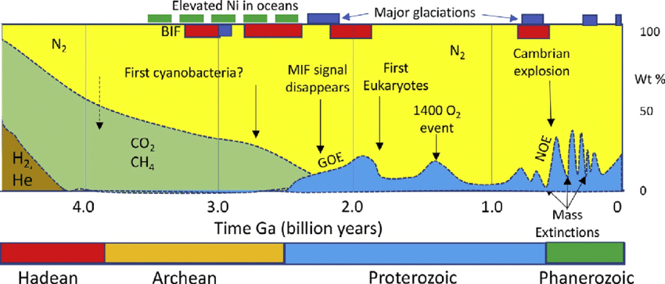
Evolution of Earth’s Atmosphere
Image from researchgate.net/publication/334115876_Evolution
Glimpsing Atmospheric Evolution for the Past Four Billion Years.
- N₂ steadily increased in the beginning to replace CO₂ and CH₄. Its appearance and creation are still a mystery to consensus science.
- The Great Oxygen Event (GOE) and the 1400 O₂ event were probably caused by the same process of photosynthesis steadily producing oxygen and then being drastically depleted during certain times by its reaction with iron-rich sinks, silica-rich sinks, and highly reactive volcanic materials.
- The BIF events are banded ironstone formations that radically reacted with available oxygen to prevent or reduce atmospheric oxygen.
- Mass extinctions show links to drops in oxygen due to the death of oxygen-producing animals/plants and possibly the rise of sinks during the peaking of volcanic activity.
- The major glaciation periods show no link to periods of increased oxygenation. MIF events which are mass-independent fractionation of sulfuric isotopes ruled out conceptual models in which global glaciation precedes or causes the evolution of oxygenic photosynthesis.
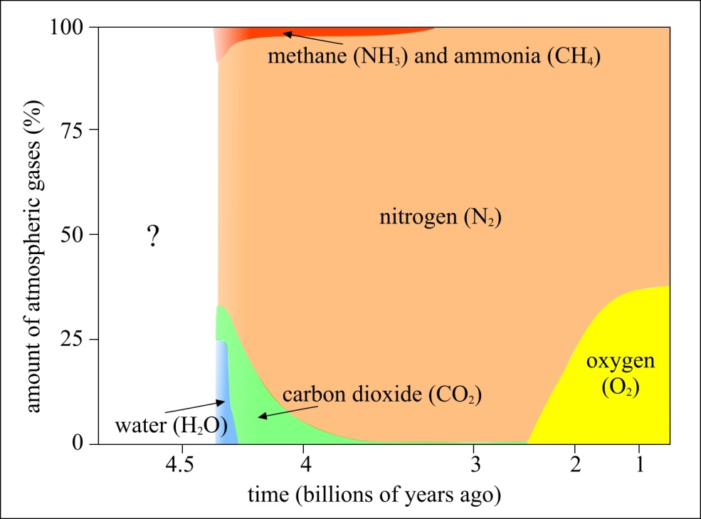
How has Atmospheric Composition Changed
Image from socratic.org, Earth Science
Amount of Atmospheric Gases Proposed for Past 4.5 Billion Years
- The above diagram proposes that water, CO₂, NH₃, and CH₄ were in the pristine atmosphere of Earth before 4 billion years ago.
- However, a proposed impactor struck Earth about 4.1 to 3.9 bya in which Earth already had these gases - in particular, water, which is theorized. The icy impactor would bring more of these volatiles and impregnate the Earth’s mantle creating much more outgassing of an already water-covered planet that was previously located 2.7 AU from the Sun.
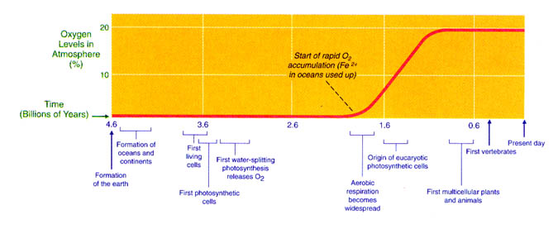
Image from the book, “Teaching about Evolution and the Nature of Science”; published by The National Academies Press (1998)
Theory of Oxygen Levels in Atmosphere During Evolution of Life
- As iron in the ocean is used up by reactive oxygen, atmospheric oxygen begins to increase to levels supporting aerobic respiration, eucaryotic photosynthetic cells, and the first multicellular plants and animals about 2 billion years ago.
- The formation of oceans and continents is shown correctly except that continents do not appear until about 3.9 bya after the Earth’s impactor event.
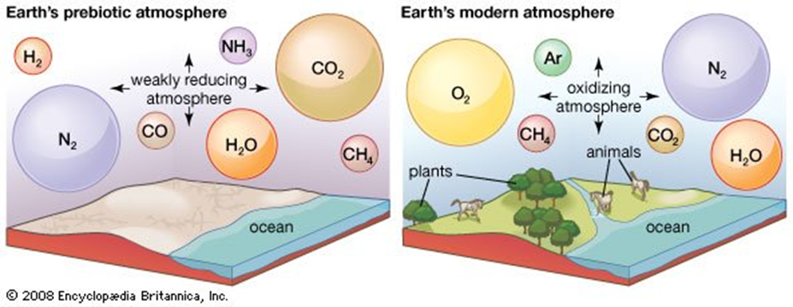
The following diagrams #1, #2, and #3 are researchers’ different versions of the Earth’s oxygen curve these past four billion years and their interpretations of what occurred.
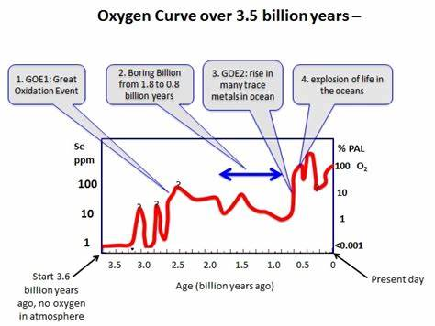
Diagram #1
Image from https://phys.org/news/2014-02-evolution-stuck-slime-billion-years.html
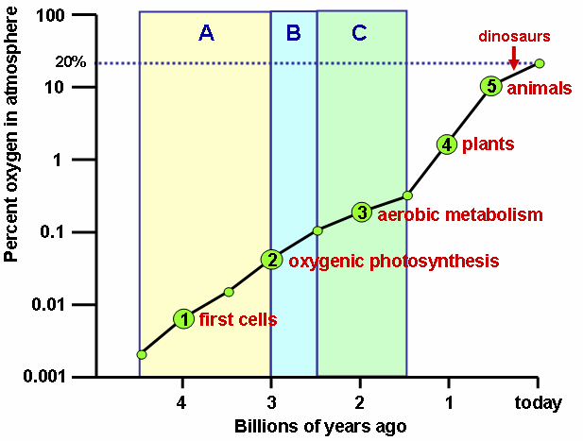
Diagram #2
Image from commons.wikimedia.org, File: Oxygen atmosphere.png
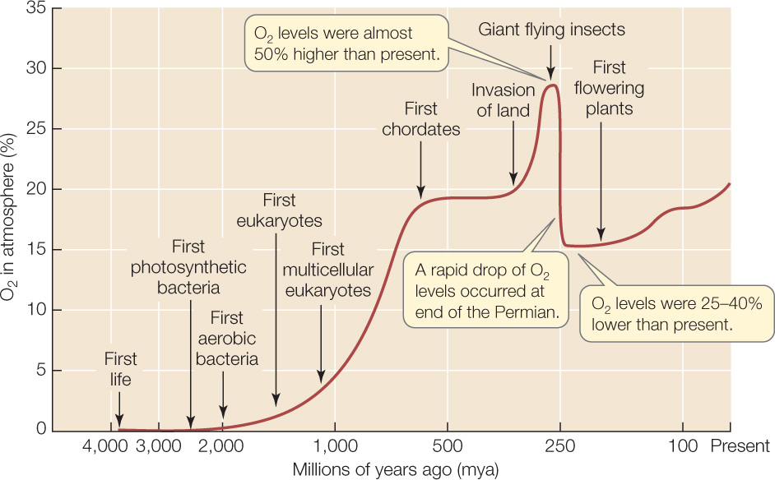
Diagram #3
Image from coursehero.com, History of Life- GOE, Eukaryotes to the Cambrian Explosion
The next diagram illustrates the link between plate tectonics during the assembly and the breakup of two past super-continents, Nuna and Rodinia, during the Proterozoic era, and atmospheric oxygen levels. During the so-called “boring billion” there is no clear evidence that glaciation and interglacial periods at the poles and on landmasses did not continue. The residual sedimentary rocks during this time with their unconformities are a testament that wasting and erosion cycles occurred. These erosion cycles could only occur if ice sheets covered the raised landmasses, retarding erosion, and then receded periodically. The warming and cooling of the oceans, the changing albedo of the ice sheets, and the Earth’s Milankovitch cycles could have created such a climatic changing process.
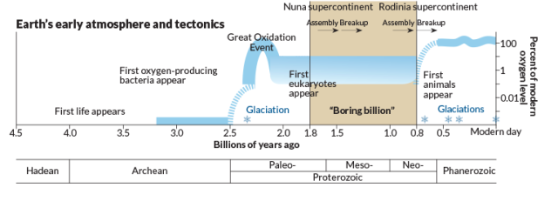
Earth’s Early Atmosphere and Plate Tectonics
Image from commons.wikimedia.org, Timeline showing the Boring Billion
The evolution of the atmosphere continues. The CO₂-O₂ cycle largely affects what happens in the atmosphere today. CO₂ emissions from humankind’s infrastructure are feared to create global warming. I believe more regard and respect should be placed on the health and thriving of our oxygen-producing organisms living in forests and the sea, which major animals need for survival.

Important Conclusions: Resolution of the First Mega-Continent Enigma
A penetrating rogue planetoid or impactor resolves many problems, especially the enigma of the first mega-continent. This ice ball delivers more needed water, carbon dioxide, methane, and nitrogen to a normally formed terrestrial planet that would have lost most of these differentiated gases during the proto-Sun’s T-Tauri phase. The impact site creates a giant crater that fills with molten rock and raises the level of Earth’s average surface. Celestial bodies in the solar system have no reason to have a raised surface since there should be leveling by the differentiation of lighter materials and gravitational compression. As observed on most bodies, the surface is level with little segregation of materials such as exists with Earth’s granitic continental crust being different from its majority of oceanic basaltic crust.
There is no reason for Earth to have a liquid ocean unless it was born at a certain distance from the Sun to avoid initially high temperatures except for its residual heat of formation. The great impactor occurred after the T-Tauri phase when the Sun became a cooler, mature star. After the Earth was displaced to a closer, warmer orbit, the combination of the Sun’s radiation, a cooler crust, and a thick enough atmosphere of CO₂ established a liquid watery surface except for the raised surface of the crater-type mega-continent. What else could have raised the mantle to such heights? Regardless, these raised surfaces should have wasted away due to erosion, except that continued vulcanism and ice sheet coverage saved the mega-continent until plate tectonics and continental drift activated mountain-building and pushed upward major plateaus.
No adequate explanation explains the current Earth-Moon system except the already formed Earth being displaced inward from its original orbit where evidence of a collision remains to this day, called the Main Belt of Asteroids. The closeness of Earth finding an orbit next to the existing Moon gave enough time for the two bodies to roughly align their orbital planes and velocities to become synchronous. NASA’s hypothesis of a glancing Great Impact fails to address numerous issues. NASA is still trying to adapt the hypothesis by recently changing the event to become a head-on collision that creates a ring of debris that then coalesces to become the Moon. This version of formation also fails to address major issues. One such issue is how the Moon and Earth have the same oxygen isotopes. This completely enigmatic result is addressed by the EMM hypothesis having Earth bring its debris from its fateful collision to the Moon’s orbit where it is swept up by the Moon during each orbit by the passing Earth.
And then geologists have several unanswerable issues such as why significant continental drift and plate tectonics are only found on the solar system’s planet Earth. More questions arise, such as what causes geological hot spots (that differ from tectonic vulcanism), the Moho layer under the lithosphere, and the different mineral compositions of the two types of crusts. A secondary differentiation of the deeply embedded impactor volatiles trying to reach the surface easily addresses these issues.
Two important geological enigmas can now be answered; the Granite Problem and the Great Unconformity (GU). The lighter volatiles of the impactor were pushed with tremendous force into Earth’s mantle of molten rock to create a certain higher ratio of mineralized silicon only found in intrusive granite. This unusual type of process called metasomatism replaces one rock with another of different mineralogical and chemical compositions. Humans have no laboratory method to produce this intrusive (bottom-crust) magma. Its origin is a total mystery that is not re-created in the rock cycle. Where does this deeply embedded rock come from that is not found on three-quarters of the Earth’s topmost mantle called the asthenosphere? Water is thought to be required to make granite due to embedded quartz and quartz deposits in adjacent country rock. How did water find its way to such depths to aid in granite formation? Only one answer comes to mind. That answer is the forceful penetration of an ice ball envisioned as striking a more molten, less viscous Earth 3.9 billion years ago.
The Great Unconformity (GU) helps with the timeline of intrusive granite rising to the surface and finally crystallizing. The mixture of magmas that formed deep in the mantle to become plutons of granite occurred about 3.9 billion years ago. This dating comes from isotopic studies of the backbones of basement granites on each continent called cratons. The GU is a distinct boundary of sandstone sediments or Paleozoic rocks overlying the basement igneous and metamorphic rocks of continental crusts worldwide. The mystery is that the dating of the rocks shows a gap in time of about 900 million years. A combination of things happened, such as continental ice sheets, the prevention of further deposition, and finally severe wasting of rocks on top of the harder basement rocks and under the quickly melting ice sheets. However, a scenario of the sluggish rising and the known slow crystallization of intrusive granite is revealed. The basement igneous rock is dated at 1.7 to 1.6 billion years ago indicating the length of time for this granite to rise to an adequate temperature/pressure regime to begin crystallizing is 3.9 – 1.7 = 2.2 billion years. It is estimated that then the lithosphere formed under the granite plutons to aid in insulating the granite from the hotter mantle-crater. The newly formed lithosphere under the continental crust would nurture the beginning of granite crystallization. Soon after the Moho layer formed, plate tectonics and continental drift could commence with faster speed. Now the Earth was ready to enter the Proterozoic era of active mountain ranges and the beginnings of multi-cellular organisms. The accelerated wasting and mixing of rock minerals off the raised mega-continent into the oceans created a miraculous brew of minerals for life to thrive on.
The Earth’s original atmosphere lost its lightest hydrogen and helium during its formation. The atmosphere retained its original gases of carbon dioxide (CO₂), water vapor (H₂O), methane (CH₄), and ammonia (NH₃). These gases were not boiled off the surface because the planet’s orbit was about 2.7 AU from the proto-Sun thereby avoiding the extremely hot temperature of the T-Tauri phase which is estimated to have reached about 1500° F inside an orbital distance of 1.5 AU. The paradigm of the Earth always being one AU from the Sun is contradicted. The atmospheric pressure of the retained gases and the cooling of the crust eventually caused the water vapor to condense and form a global ocean. There is no requirement for other celestial bodies to bring water to Earth after the T-Tauri phase as is currently perceived.
A proposed great impactor struck and penetrated Earth around 4.1 to 3.9 billion years ago (bya) causing the LHB (late heavy bombardment) and second differentiation of lighter materials via volcanism, and delivering more atmospheric gases, including water, from outgassing the impactor’s volatiles. The heat of impact reduced ammonia, nitric, and nitrous gases thereby producing the Earth’s nitrogen that was fairly stable and did not react with other chemicals, unlike the CO₂, NH₃, and CH₄ that found natural sinks in the ocean and the exposed landmasses of the newly formed mega-continent.
The only other atmospheric gas not yet formed during the early Archean Eon is oxygen (O₂). As postulated by consensus science, this gas was produced in stages. Photosynthesis started probably about 2.9 bya causing multi-cellular animals (aerobic bacteria) to produce oxygen via respiration. Oxygen did not significantly collect in the atmosphere until 2.4 bya which is called the Great Oxygen Event (GOE). Until this time, the highly reactive oxygen combined with iron and other minerals especially during the peaking of volcanism.
The levels of atmospheric oxygen rose and fell during the late Proterozoic and Phanerozoic eras due to the mass extinctions of oxygen-producing animals and plants. However, the Cambrian explosion of life caused by a large influx of a mixture of minerals into the sea permanently established plants and animals during the last 500 million years. These important minerals were created by the accelerated assembly and breakup of the last mega-continent, Pangaea. The resulting raised mountain ranges and plateaus were easily eroded or moved into the oceans and smaller seas creating the brew for life.

References
- Nield, Ted; Supercontinent; Aug 5, 2009; Harvard University Press
- Fluteau, Frederic; 2003; “Earth dynamics and climate changes”; www.sciencedirect.com
- Piper, J.D.A.; 2013; “Continental velocity through geological time: the link to magmatism, crustal accretion, and episodes of global cooling”; published by Geoscience Frontiers and found at www.researchgate.net/publication/257681242
- Donnadieu, Yannick; 2004; “A ‘Snowball Earth’ Climate Triggered by Continental Break-up Through Changes in Runoff”; Nature 428, 303-306.

- Campbell, Ian H. and Charlotte M. Allen; July 2008; “Formation of Supercontinents Linked to Increases in Atmospheric Oxygen”; Nature Geoscience 554-568 (2008)
- NASA websites:
  - https://solarsystem.nasa.gov/planets/mercury/in-depth/
  - https://solarsystem.nasa.gov/planets/venus/in-depth/
  - https://solarsystem.nasa.gov/planets/mars/in-depth/
  - https://solarsystem.nasa.gov/moons/jupiter-moons/ganymede/in-depth/
  - https://solarsystem.nasa.gov/moons/earths-moon/in-depth
- Wikipedia; https://en.wikipedia.org/wiki/Supercontinents
- Hartman, William K. and Dr. Donald R. Davis; 1981; “The Giant Impact”; Natural History Magazine
- Canup, R. and Asphaug, E: 2001; “Origin of the Moon in a giant impact near the end of the Earth’s formation”; Nature 412, 708-712.
- Mackenzie, Dana; March 2003; The Big Splat, or How the Moon Came to Be; Amazon.com: books.
- Wiechaert, U; Oct. 2001; “Oxygen isotopes and the Moon-Forming Impact”, Science 294.
- Clery, Daniel; Oct 11, 2013; “Impact Theory Gets Whacked”; Science 342.
- Wikipedia; https://en.wikipedia.org/wiki/Giant-impact_hypothesis
- Peters, Shanan E.; 2019; professor and researcher at the University of Wisconsin -Madison; Department of Geoscience; various publications including “Neoproterozoic glacial origin of the Great Unconformity”; proceedings of the National Academy of Sciences 116 (4), 1136-1145.
- Gaines, Robert; 2014; professor of geology at Pomona College; area of expertise in “The Cambrian Explosion” and sedimentary geology.
- www.phys.org: April 18, 2012; “Great Unconformity: Evidence for a geological trigger of the Cambrian explosion” by the University of Wisconsin at Madison.
- DeLucia, Michael; Dec 2012; Dept. of Geology at University of Illinois, Urbana-Campaign; “Thermochronology links denudation of the Great Conformity surface to the supercontinent cycle and Snowball Earth”.
- Guenthner, William R; Marshak, Stephen; Jan 2017; “Zircon (U-Th)/He Data Reveals Deep-Time Thermal Histories of Cratons and the Great Unconformity Surface”; published by University of Illinois Urbana-Campaign; College of Liberal Arts & Science; School of Earth, Society, and Environment; Department of Geology; geology.illinois.edu/. Also review the PBS Series Eons (Video): “When a Billion Years Disappeared” found at geology.illinois.edu/news/2020-04-28/delucias-research-highlighted-pbs-eons
- Perrin, R. and Roubault, M.; 1949; “On the Granite Problem”; the Journal of Geology: Vol 57, No 4; 9.
- Tuttle, D.F. and Keith, M.L.; Feb 1954; “The Granite Problem; Evidence from Quartz and Feldspar of a Tertiary Granite”; Geological Magazine, Vol 91; published by Cambridge University Press.
- Geological Society of America; https://gsa-foundation.org.
- Wellings, Simon; 16 September 2013; “Granites and their space problem” http://all-geo.org/metageologist/2013/09/granites-space-problem/
- https://www.britannica.com/topic/evolution-of-the-atmosphere-1703862.
- https://scijinks.gov/atmosphere-formation.
- Arizona State University: “Origin and Evolution of the Earth’s Atmosphere”; www.atmo.arizona.edu

